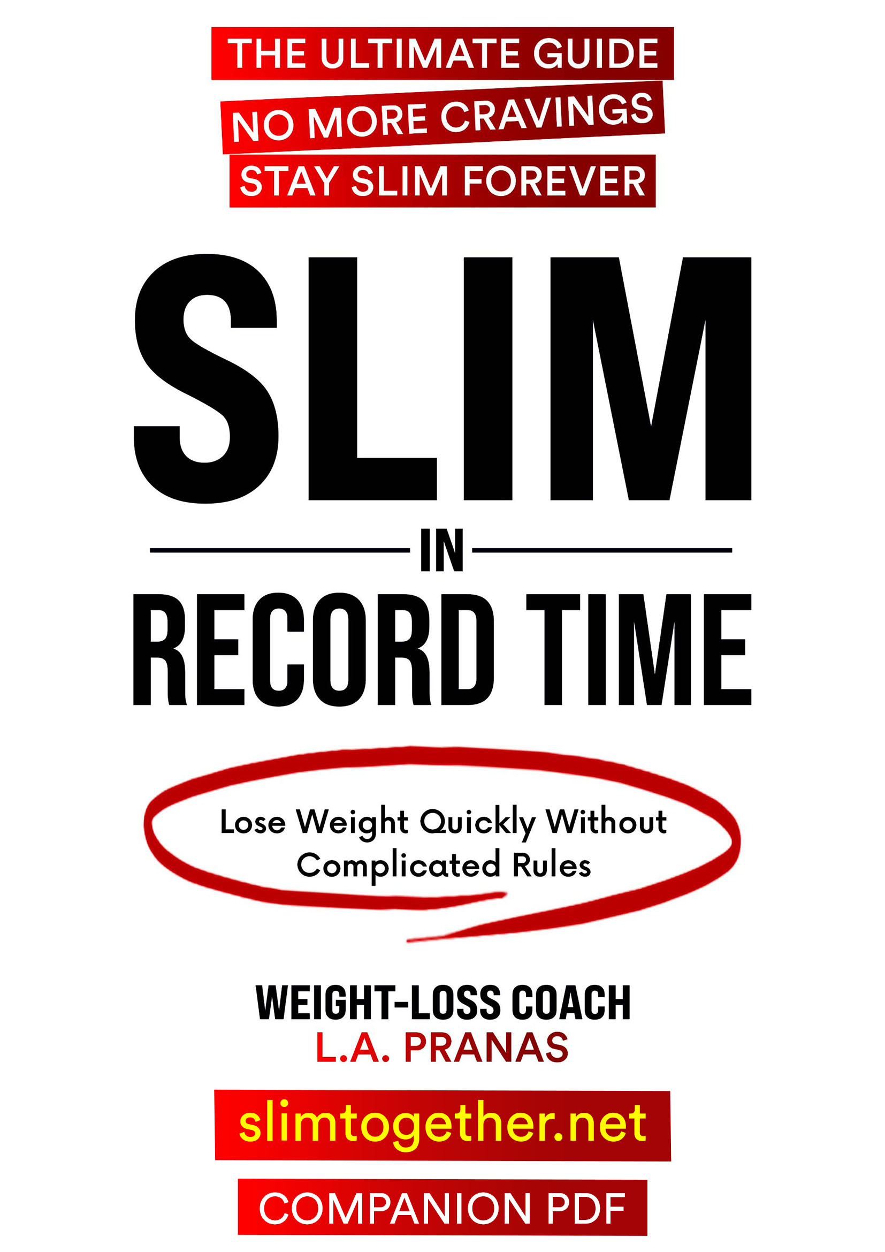

SLIM IN RECORD TIME
Your Complete Resource Guide
Companion PDF
L.A. Pranas
Includes:
✓ Vegan Soup & Mediterranean Recipes
✓ Complete Shopping Lists
✓ Weight Tracking Charts & Progress Journals
✓ Scientific References
✓ Community Access

slimtogether.net
Contents
Welcome to Your Weight Loss Journey! 5
How to Use This PDF 5
Quick Start Guide 6
The Three Phases 6
Phase 1: Two-Week Vegan Soup Blitz (Rapid Start) 6
Phase 2: Two-Week Mediterranean Phase (Consolidation) 6
Phase 3: Maintenance Cycling (Sustainable Success) 7
Your First 30 Days: A Simple Timeline 8
Optional: Adding Intermittent Fasting 8
Your Success Checklist 8
Quick Reference Card 9
Recipes & Shopping Lists 10
Part 1: Vegan Soup Phase Recipes 10
Build Your Own Soup Matrix 10
Recipe 1: Tomato & White Bean Soup 11
Recipe 2: Creamy Coconut & Red Lentil Soup 13
Recipe 3: Classic Detox Green Soup 15
Recipe 4: Spicy Metabolism-Boosting Soup 17
Recipe 5: Immune-Boosting Mushroom & Greens Soup 19
The "No-Boredom" Topping Guide 21
Vegan Soup Phase Shopping List (2-Week Supply) 22
Part 2: Mediterranean Recipes 25
Foods to Embrace vs. Avoid 25
Recipe 1: Greek Yogurt Power Bowl 26
Recipe 2: The Mediterranean Tofu Scramble 28
Recipe 3: The "Big Greek" Chickpea Salad 30
Recipe 4: One-Pan Roasted Salmon & Asparagus 32
Recipe 5: Mediterranean Loaded Sweet Potato 34
Mediterranean Phase Shopping List (2-Week Supply) 36
Part 3: Metabolism-Boosting Yogurts & Teas 38
The Super Weight-Loss Tea: Nature's "Ozempic" 38
Morning Wake-Up Drink 40
The Yogurt Connection: Gasseri For The Win 41
Probiotic Mineral Water 43
The Simple Weight-Loss Elixir with Vinegar or Lemon/Lime 44
Herbal Powerhouses: Hibiscus, Ginger, and Fenugreek Teas 46
The Satiety Shot: A Pre-Meal Secret Weapon 47
Supplements at a Glance 48
Metabolic Accelerators & Fat Burners 48
Foundation, Repair & Structure 49
Your Daily Supplement Timeline 49
Simple Moves to Accelerate Fat Loss 51
Make Every Tooth-Brushing Count 52
Balance Builder (Tandem Stance) 52
The "King" of Exercises - Simple Squats 53
Walking: Your Simple Path to Weight Loss 54
Wall Push-Ups: Your Gentle Start to Strength 55
Tracking Tools & Progress Worksheets 56
Goal Setting & Vision 57
Your Starting Point 58
12-Week Weight Tracking Chart 59
Monthly Measurements Tracker 60
Daily Progress Journal 61
Non-Scale Victories Tracker 62
Join Our Community 63
Scientific References 64
Important Considerations 73
Copyright & Legal Information 76

Welcome to Your Weight Loss Journey!
Congratulations on taking this important step toward achieving the body you deserve!
This Companion PDF is designed to work hand-in-hand with your "Slim in Record Time" audiobook. While the audiobook provides you with the complete knowledge, strategies, and motivation you need, this PDF gives you practical tools and resources to implement everything you've learned.

How to Use This PDF
This guide is designed to be both a digital reference and a printable workbook. Here's how to get the most from it:
- Print the tracking tools and keep them visible where you'll see them daily
- Choose the recipes you want to try first and prepare them in advance
- Review the Important Considerations section before starting the program
- Use the shopping lists to stock your kitchen before beginning each phase
- Join the community at slimtogether.net for ongoing support, accountability, and motivation

Quick Start Guide
This program is built on three powerful principles:
- Metabolic Cycling: Alternating between different eating patterns keeps your metabolism active and prevents plateaus
- Simplicity: Clear, easy-to-follow guidelines that eliminate confusion and decision fatigue
- Flexibility: Adaptable to your lifestyle, preferences, and individual response

The Three Phases

Phase 1: Two-Week Vegan Soup Blitz (Rapid Start)
Duration: 14 days
What You'll Eat: Three large satisfying bowls of vegan vegetable soup daily. Choose from a wide variety of organic vegetables—eat the rainbow!
Key Rules:
- No snacking between meals (keeps insulin low)
- Add 1 tablespoon extra virgin olive oil per meal
- Optional: MCT oil (start with 1/2 tsp per day, work up to 1 tsp per meal)
- Stay hydrated: water, green tea, black coffee, and unsweetened herbal tea.
What to Expect: Rapid weight loss, reduced inflammation, clearer thinking, decreased cravings, and a metabolic reset that jumpstarts your transformation.
Why It Works: This phase eliminates inflammatory foods, floods your body with nutrients, and creates optimal conditions for fat burning without triggering starvation response.

Phase 2: Two-Week Mediterranean Phase (Consolidation)
Duration: 14 days
What You'll Eat: Gluten-free Mediterranean cuisine featuring vegetables, nuts, seeds, legumes, olive oil, and moderate amounts of fruit, fish, and pastured eggs.
Key Principles:
- Focus on whole, unprocessed foods
- Generous use of extra virgin olive oil
- Include fatty fish 1-2 times per week
- Completely gluten-free (no wheat, barley, rye)
- Moderate portions—listen to your body
What to Expect: Continued steady weight loss, increased energy, improved satisfaction, and development of sustainable eating habits.
Why It Works: This phase provides greater variety while maintaining metabolic momentum. It guides you how to eat for lifelong health and weight maintenance.

Phase 3: Maintenance Cycling (Sustainable Success)
Duration: Ongoing—customize to your needs
The Strategy: Continue alternating between Soup and Mediterranean phases based on your goals and results.
Common Cycling Patterns:
- For Continued Weight Loss: 1 week Soup / 2 weeks Mediterranean
- For Slower Weight Loss: 3 days Soup / 11 days Mediterranean
- For Maintenance: 1 day Soup / 6 days Mediterranean (or Mediterranean daily with intermittent fasting)
Why It Works: Cycling prevents metabolic adaptation, provides psychological relief, and gives you a tool to manage your weight for life.

Your First 30 Days: A Simple Timeline
Days | What You're Doing
Day 1 | Take "before" photos and measurements.  Start the Vegan Soup Blitz. Prepare the soup you like.
Days 1-14 | Follow Soup Phase: three large bowls daily. Track your weight weekly.
Days 15-28 | Begin Mediterranean Phase. Enjoy greater variety while maintaining progress.
Day 29+ | Choose your cycling pattern based on results. Continue until you reach your goal!

Optional: Adding Intermittent Fasting
Once you're comfortable with the dietary phases (usually after 4-6 weeks), you can add intermittent fasting to accelerate results and enhance metabolic benefits.
Two Popular Approaches:
- Midday-to-Evening Window: Eat between 12 PM and 6-8 PM (16-18 hour fast)
- Early Window: Eat between 8 AM and 2-4 PM (16-18 hour fast)
Gradual Implementation: Start with a 12-hour eating window and extend gradually by 1 hour every 1-2 weeks. Your body will adapt naturally without feeling deprived.

Your Success Checklist
- Stock your kitchen with soup ingredients
- Hide or remove junk food from your home.
- Set up a tracking system (journal, app, or worksheets)
- Told supportive friends/family about your commitment
Remember: This isn't a temporary diet—it's a sustainable lifestyle that will serve you for years to come. Take it one day at a time, trust the process, and watch as your body transforms.

Quick Reference Card

1. The Golden Rule of Eating (Food Order)
Reduce glucose spikes by up to 73% just by changing the order in which you eat.
Step 1: Fiber First. Start with vegetables (salad, roasted, fermented, or soup). This creates a mesh in your gut to slow carbohydrate absorption.
Step 2: Protein & Healthy Fats. Eat your lentils, nuts, seeds, yogurt, fish, tofu, avocado, and healthy oils.
Step 3: Carbs (Last). Save the rice, potatoes, sourdough bread, or dessert for the very end.
2. How Much: Eat until you're satisfied, not stuffed (about 70-80% full). Your digestion, weight, and energy will thank you.
3. Timing:
- Finish eating 3+ hours before bed
- Aim for 16-18 hour overnight fast (e.g., 6pm to 10am)
- Simple exercises for 10 minutes after meals
4. Daily Essentials:
- 1 tbsp extra virgin olive oil per meal
- Water with lemon/vinegar before your main meals
- No snacking in between
- Stay hydrated: aim for 8+ glasses daily
- Sleep: Aim for 7–8 hours nightly. Sleep deprivation spikes hunger hormones and blocks fat burning.
5. When Cravings Strike
The 10-Minute Rule: Tell yourself "I can have this in 10 minutes." Set a timer, redirect your attention. Most cravings pass.
6. The Water Test: Feeling hungry? Drink a full glass of water first and wait 20 minutes. If the hunger fades, you were just thirsty. If not, eat a healthy, satisfying meal.

7. Your Weight Trigger Point
Goal Weight: _________ + 5 lbs/2.3 kg = Trigger Point: _________
If you reach your Trigger Point, return to the Vegan Soup Phase for 2-3 days.

Recipes & Shopping Lists
This section provides everything you need to prepare delicious, nutritious meals for both phases of the program. All recipes are designed for maximum results.

Part 1: Vegan Soup Phase Recipes
These soups form the foundation of your rapid start phase. Each recipe serves 4-6 bowls. Prepare 2-3 recipes for variety throughout the week.

Build Your Own Soup Matrix
Mix and match ingredients from each category to create endless varieties:
Category | Choose From
Leafy Greens | kale, spinach, swiss chard, collard greens, bok choy, romaine lettuce, chicory, watercress, mustard greens
Cruciferous | cauliflower, cabbage, broccoli, brussels sprouts, kohlrabi
Aromatics | onions, garlic, leeks, scallions, shallots, ginger, celery, fennel, chili peppers
Root Vegetables | sweet potatoes, carrots, turnips, radishes, zucchini, beets, rutabaga, parsnips, celeriac, artichokes
Protein | 1/2 cup dried or 1 can daily: lentils, chickpeas, black beans, kidney beans, butter beans, white beans, edamame, etc
Nuts, Seeds | up to 2 ounces or 60g daily: walnuts, pistachios, hazelnuts, blanched almonds, pecans, hemp hearts, basil seeds, chia seeds, and flax seeds
Spices | flavor and metabolic enhancement (turmeric, ginger, black pepper, any spices of your choice)
Fresh Herbs | micronutrients and flavor (parsley, cilantro, basil, mint, arugula, oregano, rosemary, any fresh herbs you like)
Essential Fats | 1 tbsp EVOO (extra virgin olive oil) per meal, MCT oil (start 1/2 tsp per day, work up to 1 tsp per meal). Other great oils to use: avocado oil, coconut oil, sesame oil
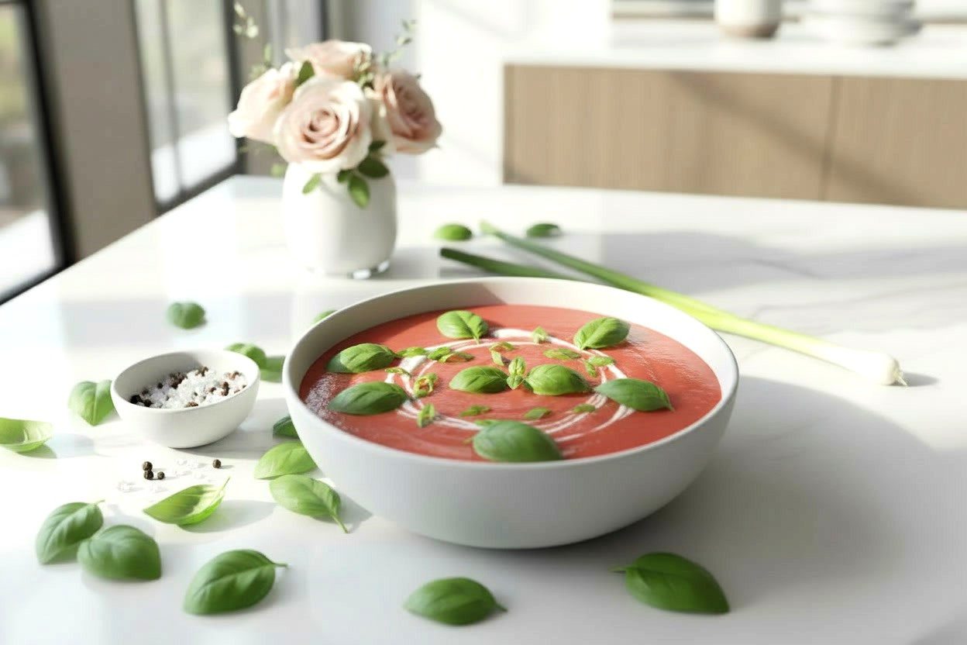

Recipe 1: Tomato & White Bean Soup
Serves: 4 bowls | Prep: 5 min | Cook: 10 min
Chef’s Note: It takes minutes to prep. The beans replace heavy cream, creating a velvety texture while packing a protein punch.
Ingredients:
- 1 can (14 oz or 400g) cannellini beans, drained and rinsed
- 2 cans (14 oz or 400g each) chopped tomatoes
- 4 spring onions (scallions)
  - Prep: Roughly chop the white parts for the soup; slice the green parts thinly to use as garnish.
- 1/4 cup (60g) unsweetened, plain soy or coconut yogurt (Full fat)
- 1/2 cup (15g) fresh basil leaves
- 1 tbsp extra virgin olive oil
- 1 tbsp tomato purée (paste)
- 1/2 tsp sea salt (to taste)
- Black pepper (generous grind)
- Water (1/2 to 1 cup, depending on desired thickness)
Instructions:
- Blitz: Place the drained beans, chopped tomatoes, white parts of the spring onions, yogurt, basil leaves, olive oil, and tomato purée into a blender.
- Season: Add a generous pinch of sea salt and black pepper. Blend on high speed until completely smooth and creamy. The beans should be fully pulverized to thicken the soup.
- Simmer: Pour the mixture into a saucepan. Stir in 1/2 cup of water (add more if you prefer a thinner soup). Bring to a gentle bubble over medium heat and simmer for 10 minutes.
  - Why cook it? Even though the ingredients are edible, this short simmer cooks out the raw edge of the onion.
- Serve: Taste and adjust salt if needed. Ladle into bowls and top with the reserved green spring onions and extra fresh basil.

Nutritional Information
Per Serving (1 Bowl) (Calculated based on 4 servings)
- Calories: 145
- Carbs: 19g | Fiber: 6g | Protein: 8.5g | Fat: 4.5g
Key Benefit: This soup provides the comfort of a "Cream of Tomato" soup but uses white beans instead of cream, delivering 6g of fiber per bowl to support digestion and weight loss.
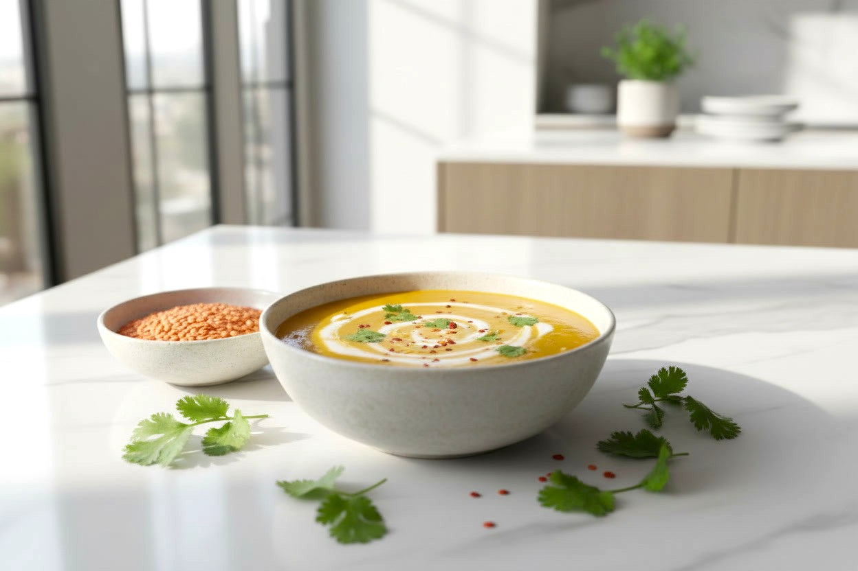

Recipe 2: Creamy Coconut & Red Lentil Soup
Serves: 4 bowls | Prep: 10 min | Cook: 35 min
Chef’s Note: Do not throw away the cilantro stems! They hold more flavor than the leaves and are perfect for infusing the broth. The red lentils will break down as they cook, naturally thickening the soup without needing flour or cream.
Ingredients:
- 1 tbsp coconut oil (or olive oil)
- 1 large onion, finely chopped
- 1 tsp sea salt (to taste)
- 2 cloves garlic, crushed
- 2 inch (5 cm) piece of fresh ginger, peeled and finely chopped
- 1 tbsp curry powder
- 1/4 tsp red pepper flakes (for a metabolism kick)
- 3/4 cup (150g) dry red lentils, rinsed and drained
- 1 can (14 oz or 400g) chopped tomatoes
- 1 cup (20g) cilantro stems, finely chopped
- 2 1/2 cups (600ml) water
- Generous grind of black pepper
- 1 can (13.5 oz or 400ml) light coconut milk (shake well before opening)
- 1/4 cup (5g) fresh cilantro leaves, for garnish
Instructions:
- The Base: Heat the coconut oil in a medium saucepan over medium-high heat. Add the onion and a pinch of salt. Fry for 6–8 minutes, stirring frequently, until the onion is soft and starting to caramelize (turn golden).
- Bloom the Spices: Add the garlic, ginger, curry powder, and red pepper flakes. Fry for 2 minutes, stirring constantly. This prevents the spices from tasting "raw" and fully releases their aroma.
- Combine: Stir in the rinsed lentils and coat them in the spiced onion mixture for 1 minute. Add the chopped tomatoes, chopped cilantro stems, water, 1 tsp salt, and black pepper.
- The Coconut Trick: Pour the coconut milk into a small bowl and whisk briefly to ensure it is smooth. Reserve 1/4 cup (60ml) of the milk for garnish later. Pour the rest into the pot.
- Simmer: Bring the soup to a boil, then reduce the heat to medium-low. Simmer gently for 25 minutes, stirring occasionally, until the lentils are soft and have started to break down.
  - Texture Check: If the soup is too thick for your liking, add splashes of water (about 1/2 cup) until it reaches your desired consistency.
- Serve: Ladle into four bowls. Drizzle the reserved coconut milk over the top (this looks amazing and tastes great) and sprinkle with the fresh cilantro leaves.

Nutritional Information
Per Serving (1 Bowl)
- Calories: 235
- Carbs: 28g | Fiber: 6g | Protein: 10g | Fat: 9g
Key Benefit: Red lentils are a powerhouse of plant-based protein and fiber, making this the most filling soup of the collection. The healthy fats from the coconut help with nutrient absorption.
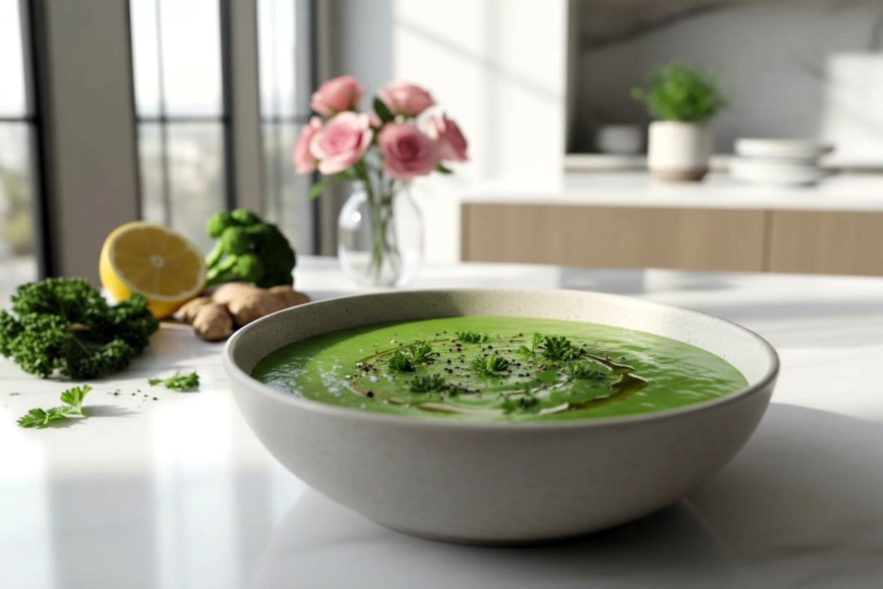

Recipe 3: Classic Detox Green Soup
Serves: 4-6 bowls | Prep: 15 min | Cook: 25 min
Chef’s Note: This soup is designed for volume eating. It is hydrating, rich in fiber, and the addition of lemon at the end cuts the "grassy" flavor of the greens, making it bright and delicious.
Ingredients:
- 1 tbsp extra virgin olive oil
- 1 large onion, diced
- 2 stalks celery, chopped
- 1 tsp sea salt (to taste)
- 4 cloves garlic, minced
- 1 tsp turmeric powder
- 1/2 tsp black pepper (essential to activate the turmeric)
- 2 medium zucchini, chopped
- 2 cups (150g) broccoli florets
- 6 cups (1.5 liters) vegetable broth (low-sodium)
- 4 cups (120g) chopped kale or spinach (stems removed)
- 1 inch (2.5 cm) fresh ginger, grated (add at the end for maximum flavor)
- 1 lemon, juiced
- Fresh parsley for garnish
Instructions:
- Build the Base: Heat the olive oil in a large pot over medium heat. Add the onion, celery, and a pinch of salt. Sauté for 5–7 minutes until the onions are translucent and fragrant. Add the garlic and cook for 1 more minute
- Bloom the Spices: Stir in the turmeric and black pepper. coating the vegetables. Cooking spices in the oil for 30 seconds "wakes them up" and intensifies their health benefits.
- Simmer: Add the zucchini, broccoli, and vegetable broth. Increase heat to bring to a boil, then reduce to a simmer. Cover and cook for 10–12 minutes.
  - Tip: Don't overcook the broccoli! It should be tender but still bright green to preserve nutrients.
- Wilt the Greens: Stir in the kale (or spinach) and the grated ginger. Simmer uncovered for 2–3 minutes until the greens are wilted.
- The Finish: Remove the pot from the heat. Stir in the fresh lemon juice. Taste the soup and season with sea salt as needed.
- Texture: For the best experience, use an immersion blender to pulse the soup 3 or 4 times. You want a creamy base but with some nice chunks of vegetables remaining for texture.
- Serve: Ladle into bowls and garnish with fresh parsley and a pinch of red pepper flakes if you like heat.
Variations:
- Protein Boost: Add 1/2 cup rinsed red lentils in step 3 (simmer time will increase to 20 mins).
- Creamy Upgrade: Swap one zucchini for 1/2 an avocado added right before blending for a silky texture without dairy.
Nutrition Facts (Per Bowl)
- Calories: 105
- Carbs: 14g | Fiber: 4g | Protein: 4g | Fat: 3.5g
- Note: Estimates based on 5 servings per pot.
- With Protein Boost (Lentils): Adds approx. +70 calories and +5g protein per bowl.
- With Creamy Upgrade (Avocado): Adds approx. +30 calories and +2.5g healthy fats per bowl (if replacing zucchini).
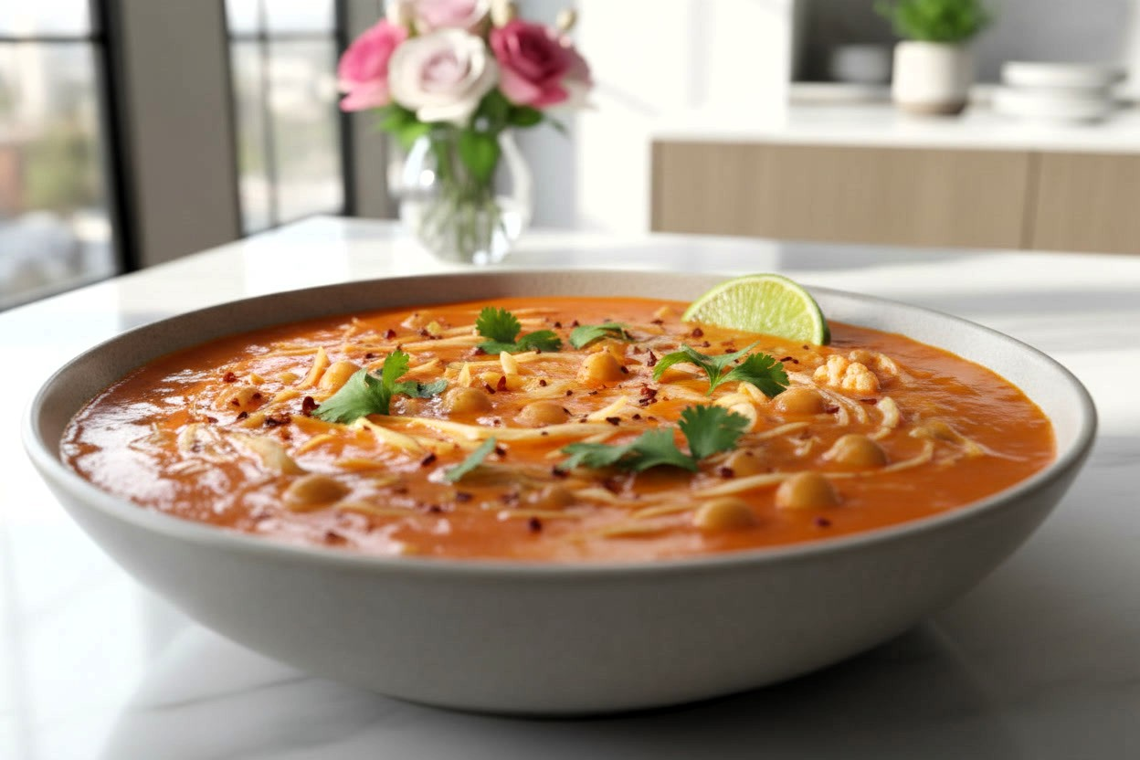

Recipe 4: Spicy Metabolism-Boosting Soup
Serves: 4-6 bowls | Prep: 15 min | Cook: 30 min
Chef’s Note: Ideally, slice the cabbage very thinly (like coleslaw). It creates a wonderful noodle-like texture that makes the soup feel much heartier and satisfying.
Ingredients:
- 1 tbsp extra virgin olive oil
- 1 large onion, diced
- 1 red bell pepper, diced
- 1 tsp sea salt (to taste)
- 4 cloves garlic, minced
- 2 inch (5cm) piece fresh ginger, grated
- 2 tsp cumin powder
- 1 tsp paprika
- 1/4 to 1/2 tsp cayenne pepper (start small, it’s hot!)
- 2 medium tomatoes, diced (or 1 cup / 240ml canned crushed tomatoes)
- 3 cups (300g) cauliflower florets (cut into small, bite-sized pieces)
- 2 cups (150g) cabbage, thinly shredded
- 1 can (15 oz or 425g) chickpeas, rinsed and drained
- 6 cups (1.5 liters) vegetable broth
- 1 lime, juiced (balances the spice and cabbage flavor)
- Fresh cilantro for garnish
Instructions:
- The Aromatic Base: Heat the olive oil in a large pot over medium heat. Add the onion, red bell pepper, and a pinch of salt. Sauté for 5–6 minutes until soft.
- Bloom the Spices: Add the garlic, ginger, cumin, paprika, and 1/4 tsp cayenne pepper. Stir constantly for 60 seconds.
  - Why this matters: Frying the spices releases their essential oils, making the soup taste rich rather than dusty.
- Deglaze: Add the diced tomatoes and stir well, scraping up any spices stuck to the bottom of the pot. Cook for 2 minutes until the tomatoes break down slightly.
- The Simmer: Add the cauliflower, shredded cabbage, chickpeas, and vegetable broth. Increase heat to boil, then reduce to low, cover, and simmer for 20 minutes.
- Final Seasoning: Taste the soup. If you want more heat, add another pinch of cayenne now. Stir in the lime juice. Season with sea salt to taste.
- Serve: Ladle into bowls and top with plenty of fresh cilantro.
Metabolism Boost: The combination of capsaicin (cayenne), ginger, and the protein from chickpeas creates a high "thermic effect," requiring your body to burn more energy during digestion.
Nutrition Facts (Per Bowl)
- Calories: 180
- Carbs: 24g | Fiber: 7g | Protein: 6g | Fat: 4g
Key Benefit: The high fiber content combined with protein from the chickpeas helps keep you full for hours.

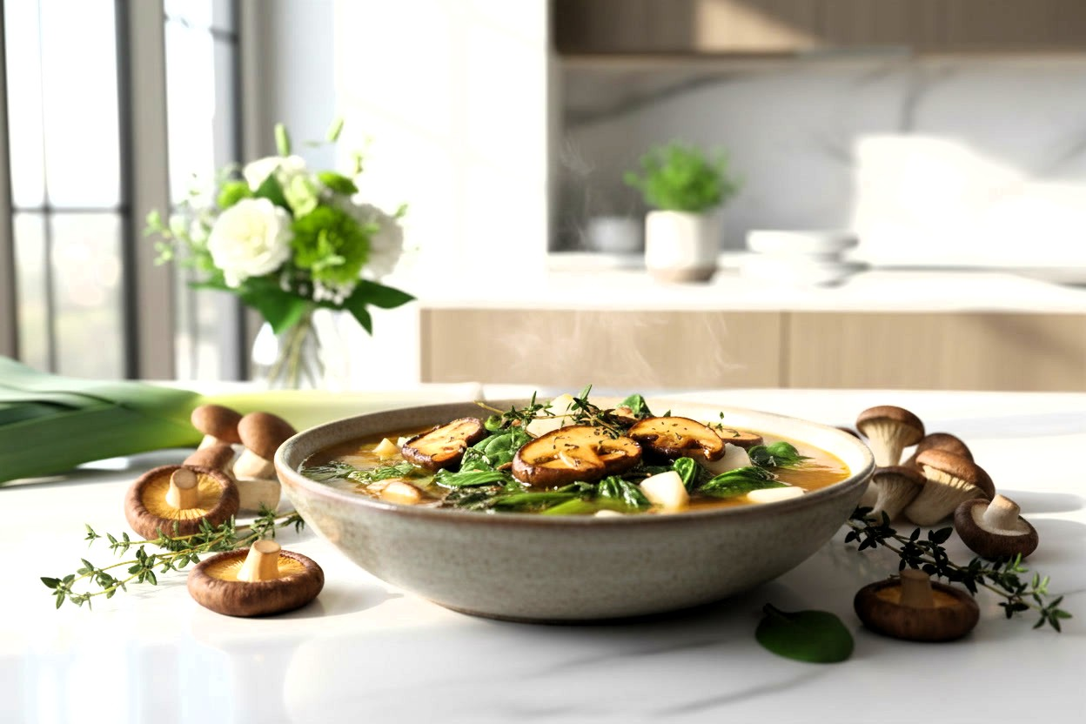

Recipe 5: Immune-Boosting Mushroom & Greens Soup
Serves: 4-6 bowls | Prep: 15 min | Cook: 25 min
Chef’s Note: By using turnips instead of potatoes, you get that satisfying starchy texture for a fraction of the calories. The key here is browning the mushrooms well!
Ingredients:
- 1 tbsp extra virgin olive oil
- 4 cups (300g) mixed mushrooms (cremini, shiitake, oyster), sliced
- 1 large leek, white and light green parts only (sliced and rinsed thoroughly)
- 1/2 tsp sea salt (to taste)
- 5 cloves garlic, minced
- 2 tsp dried thyme
- 1 tsp turmeric powder
- 1/2 tsp black pepper
- 2 medium turnips, peeled and cut into small 1/2 inch (1 cm) cubes
- 6 cups (1.5 liters) vegetable broth
- 1 tbsp Tamari, soy sauce, or coconut aminos
- 3 cups (90g) bok choy or swiss chard, chopped (stems separated from leaves)
- 2 cups (60g) baby spinach
- 1 tbsp fresh lemon juice
Instructions:
- Sear the Mushrooms: Heat the olive oil in a large pot over medium-high heat. Add the mushrooms in a single layer (do this in two batches if your pot is small). Cook undisturbed for 3 minutes until golden brown, then stir.
  - Chef Tip: Browning the mushrooms creates a great base flavor that boiling cannot achieve.
- Aromatics: Turn the heat down to medium. Add the sliced leeks and a pinch of salt. Sauté for 4–5 minutes until the leeks are soft and sweet. Add the garlic, thyme, turmeric, and black pepper. Cook for 1 minute until fragrant.
- The Simmer: Add the cubed turnips, vegetable broth, and tamari/soy sauce. Scrape the bottom of the pot to release any browned bits. Bring to a boil, reduce heat to low, cover, and simmer for 15 minutes (or until turnips are tender like a cooked potato).
- Stems First: If using Bok Choy or Chard, add the chopped stems to the pot first and cook for 2 minutes.
- Greens Last: Stir in the Bok Choy/Chard leaves and the spinach. Cook for just 1–2 minutes until wilted and bright green.
- Brighten: Remove from heat. Stir in the lemon juice. Taste—it might need a pinch of salt, but the tamari usually salts it perfectly.
Benefits:
- Immune Defense: Shiitake mushrooms are famous for supporting the immune system.
- Vitamin D: Mushrooms are one of the few produce items that contain Vitamin D.
- Low-Carb Comfort: The turnips mimic the texture of potatoes, satisfying carb cravings without spiking insulin.
Nutrition Facts (Per Bowl)
- Calories: 95
- Carbs: 14g | Fiber: 4g | Protein: 5g | Fat: 3g

The "No-Boredom" Topping Guide
Same soup, completely different experience. These simple additions transform yesterday's leftovers into today's new favourite.

🥜 The Crunch Factor
- Toasted Pumpkin Seeds — Earthy and satisfying. Perfect on the Spicy Soup or Green Soup.
- Crispy Roasted Chickpeas — Save a handful from your Spicy Soup prep, roast until golden, and scatter on top like croutons.
- Crushed Walnuts — Rich and buttery. Made for the Mushroom Soup.

🌀 The Flavour Swirls One teaspoon, totally different meal
- Pesto Swirl — Stir into the Tomato Soup for an instant Italian twist.
- Tahini-Lemon Drizzle — Adds nutty, Mediterranean richness to the Lentil Soup. Mix equal parts tahini and lemon juice.
- Chilli Oil or Hot Sauce — Transforms the Green Soup with a warming kick.

💪 The Protein Boosters Extra staying power, minimal effort
- Hemp Hearts — Sprinkle 1 tablespoon on any soup for a subtle nutty flavour and 3g of bonus protein.
- Nutritional Yeast — Gives the Green Soup a satisfying "cheesy" depth without dairy.

Start with one topping per bowl. By week two, you'll be creating your own signature combinations.

Vegan Soup Phase Shopping List (2-Week Supply)
This list covers all ingredients needed for the 5 recipes plus the "No-Boredom Toppings." Adjust quantities based on household size.
Fresh Produce
- Leafy Greens: 5–7 large bunches (Mix of Kale, Spinach, Bok Choy, and Swiss Chard)
- Broccoli: 2–3 large heads
- Cauliflower: 2 large heads
- Cabbage: 1 large head (Green or Savoy)
- Zucchini: 4–5 medium
- Turnips: 4–5 medium (Essential for Mushroom Soup)
- Mushrooms: 1.5 – 2 lbs (approx. 800g) mixed varieties (Cremini, Shiitake, Oyster)
- Celery: 1 bunch
- Leeks: 2 large
- Spring Onions (Scallions): 1 bunch (Essential for Tomato Soup)
- Onions: 8–10 large (Yellow or White)
- Garlic: 4–5 bulbs
- Fresh Ginger: 1 large root (approx. 5 inches / 12 cm)
- Bell Peppers: 2–3 (Red or Orange)
- Tomatoes (Fresh): 4–5 medium (Optional: mainly for Spicy Soup, can substitute canned)
- Lemons: 5–6 (Increased count for Soups + Tahini Drizzle)
- Limes: 3–4 (Essential for Spicy soup)
- Fresh Herbs:
  - Parsley (2 bunches)
  - Cilantro (2 bunches)
  - Basil (1 large bunch - Essential for Tomato Soup)
- Avocados: 2–3 (Optional: for "Creamy Green Soup" variation)
Refrigerated
- Unsweetened, plain Soy or Coconut Yogurt: 1 small tub (For Tomato Soup & Garnish)
Pantry Essentials
- Vegetable Broth (Low-Sodium): 10–12 cartons (32 oz or 1 liter each) OR 2 jars high-quality vegetable bouillon paste (Highly recommended).
- Extra Virgin Olive Oil: 1 large bottle
- Coconut Oil: 1 jar (Preferred for Lentil Soup, or just use Olive Oil)
- Light Coconut Milk: 2–3 cans (Essential for Lentil Soup)
- Tamari, Soy Sauce, or Coconut Aminos: 1 bottle (Essential for Mushroom Soup)
- Tomato Purée (Paste): 1 small tube or jar
- Canned Chopped Tomatoes: 6–8 cans (14 oz / 400g each)
- Canned Chickpeas: 3–4 cans (15 oz or 425g each) (Increased quantity to allow for roasting as a topping)
- Canned Cannellini (White) Beans: 2–3 cans (14 oz / 400g each)
- Red Lentils (Dried): 1 bag (Essential for Lentil Soup)
- Tahini: 1 jar (For the Lemon-Tahini Drizzle)
- Vegan Pesto: 1 jar (For the Tomato Soup Swirl)
- Hot Sauce or Chili Oil: 1 bottle (For the Green Soup kick)
- MCT oil (C8 or C8/C10 blend): 1 bottle (Optional: for metabolic support)
Nuts, Seeds & Boosters (For Toppings)
- Raw Pumpkin Seeds (Pepitas): 1 small bag
- Walnuts: 1 small bag (roughly chopped)
- Hemp Hearts (Seeds): 1 small bag
- Nutritional Yeast: 1 canister/bag (For cheesy flavor without dairy)
Spices & Seasonings
- Sea Salt: (Pink Himalayan or flaky sea salt, iodised)
- Black Peppercorns: (with a grinder)
- Turmeric Powder
- Cumin Powder
- Paprika
- Curry Powder (Medium)
- Cayenne Pepper (or Red Pepper Flakes)
- Dried Thyme
Beverages
- Herbal teas: Green tea, Ginger tea, Hibiscus tea, etc.
- Black coffee
- Filtered water
- Mineral water
- Sparkling Water (Great for transitioning off soda)

Part 2: Mediterranean Recipes
The Mediterranean phase offers more variety while maintaining your weight loss momentum. Focus on whole, unprocessed foods with generous amounts of healthy fats.

Foods to Embrace vs. Avoid
EMBRACE (YES)
Vegetables: Unlimited leafy greens, cruciferous vegetables, alliums, colorful & root vegetables. Aim for at least two-thirds of your plate covered in vegetables at most meals
Healthy Fats: EVOO (extra virgin olive oil) as primary, avocado, olives, nuts & seeds, dairy
Proteins: Legumes, nuts, seeds, dairy, wild-caught fish, eggs, pastured chicken (in moderation)
Dairy: in moderation, yogurt, sheep/goat cheese.
Gluten-Free Grains: Quinoa, sorghum, millet (in moderation)
Healthy Sweeteners: allulose, pure stevia, monk fruit, raw honey (up to 1-2 tsp per day)
Spices: flavor and metabolic enhancement (turmeric, ginger, black pepper, any spices of your choice)
Fresh Herbs: micronutrients and flavor (parsley, cilantro, basil, mint, any fresh herbs you like)
Fruits: Berries (priority), avocados, moderate amounts of other fruits
.
AVOID (NO)
Gluten Grains: Wheat, barley, rye, spelt, kamut, couscous, semolina
Industrial Oils: Soybean, corn, canola, cottonseed, sunflower, safflower oil
Sugar & Processed: any sugar, artificial sweeteners, ultra-processed foods
High-Lectin Foods: Unsoaked beans, peanuts, cashews

A Note on Alcohol. While red wine is part of the Mediterranean lifestyle, alcohol acts as a "pause button" on weight loss because your liver prioritizes processing alcohol over burning fat.
For Fastest Results: Avoid all alcohol during weight-loss phases.
For Social Flexibility: Limit to 1–2 glasses of dry red wine or champagne per week. Avoid beer, spirits, and sugary cocktails.
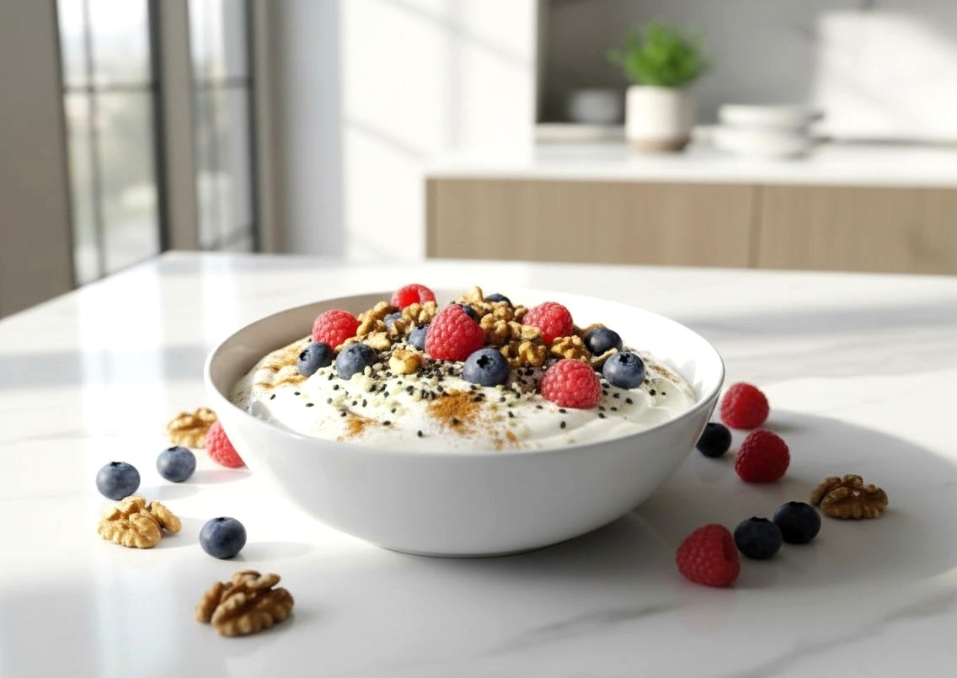

Recipe 1: Greek Yogurt Power Bowl
Serves: 1 bowl | Prep: 3 min | Cook: 0 min
Chef’s Note: This is the ultimate quick breakfast. We use full-fat yogurt here because the healthy fats are essential for keeping you full and helping your body absorb the fat-soluble vitamins (A, D, E, K) from the toppings.
Ingredients:
- 3/4 cup to 1 cup (170g – 200g) full-fat unsweetened Greek yogurt (or unsweetened coconut, soy, or almond yogurt for vegans)
- 1/2 cup (75g) fresh berries (raspberries, blueberries, or strawberries)
- 1 tbsp (10g) walnuts, roughly chopped
- 1 tbsp (10g) hemp hearts (shelled hemp seeds)
- 1 tsp chia seeds
- A generous pinch of cinnamon
Instructions:
- The Base: Spoon the yogurt into a bowl. Smooth the top with the back of your spoon to create a little "well" for the toppings.
- The Boosters: Stir in the Chia seeds and cinnamon (or just sprinkle them on top for texture).
  - Chef's Tip: If you prefer a softer texture, stir the chia seeds in and let the bowl sit for 2 minutes while you make your coffee. The seeds will plump up slightly.
- The Crunch: Top with the chopped walnuts, hemp hearts, and fresh berries.
Chef's Tip: If the berries are tart, you can add 1 tsp of raw honey. The cinnamon also adds warmth that mimics sweetness. Ideally, try to use less honey over time to allow your palate to adjust to the natural sweetness of the fruit.
Nutrition Facts (Per Bowl) (Calculated with 1 cup full-fat yogurt & chia seeds)
- Calories: 340
- Carbs: 16g | Fiber: 6g | Protein: 24g | Fat: 20g
Key Benefit: The combination of protein (from yogurt) and Omega-3 fatty acids (from chia, hemp, and walnuts) supports brain health and keeps you satiated for hours.

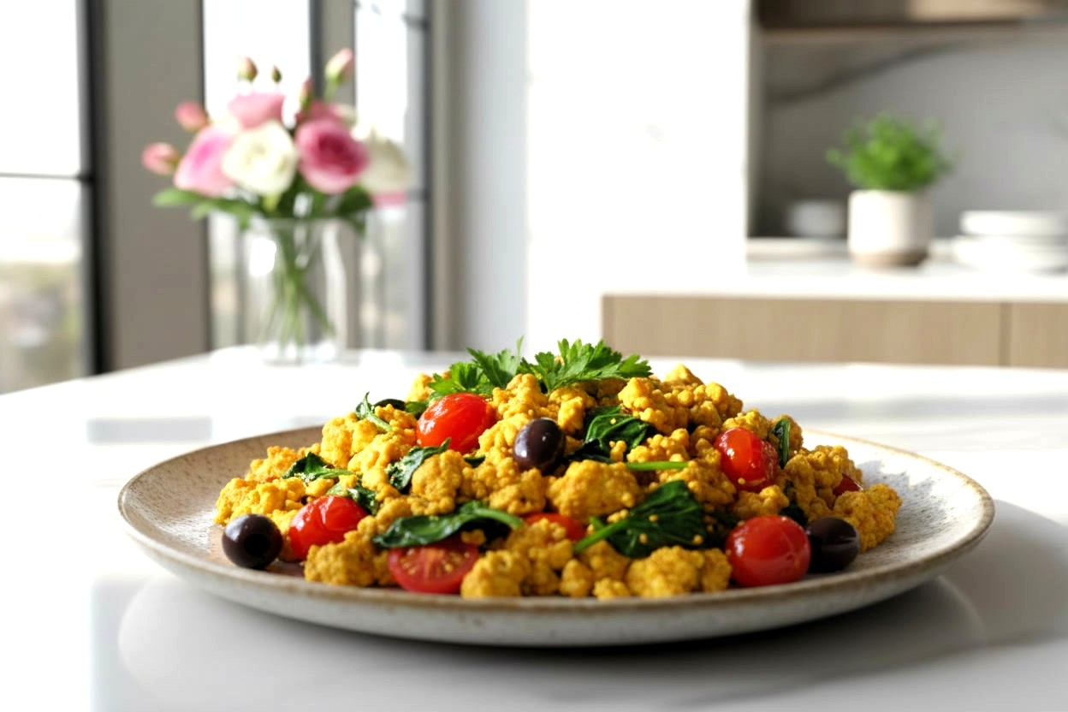

Recipe 2: The Mediterranean Tofu Scramble
Serves: 1 large plate | Prep: 5 min | Cook: 7 min
Chef’s Note: Tofu is a protein powerhouse that acts like a flavor sponge, absorbing the savory garlic and turmeric spices perfectly. This dish gives you the high-protein satisfaction of a hearty breakfast without the cholesterol, helping to keep your energy steady all morning.
Ingredients:
- 1/2 block (approx. 7 oz or 200g) firm or extra firm tofu, drained
- 1 tbsp nutritional yeast (savory, "cheesy" flavor)
- 1/2 tsp turmeric powder
- 1/2 tsp garlic powder
- 1/4 tsp sea salt (plus more to taste)
- 1/4 tsp black pepper
- 1 tbsp extra virgin olive oil
- 1 cup (30g) fresh spinach
- 6-8 cherry tomatoes, halved
- 2 tbsp Kalamata olives, pitted and sliced (optional, adds a salty kick)
- Fresh parsley or basil (for garnish)
Instructions:
- The Crumble: Pat the tofu dry with a paper towel. Over a bowl, use your hands to crumble the tofu into bite-sized chunks. Sprinkle the nutritional yeast, turmeric, garlic powder, 1/4 tsp salt, and 1/4 tsp pepper over the tofu and toss to coat evenly.
- The Sizzle: Heat the olive oil in a non-stick pan over medium heat. Add the seasoned tofu crumble. Cook for 3–4 minutes, stirring occasionally, until the tofu is hot and slightly browned on the edges.
- The Veggies: Push the tofu to one side of the pan. Add the cherry tomatoes and spinach to the empty side. Cook for 2 minutes until the spinach wilts and tomatoes soften.
- Combine: Mix everything together. Stir in the olives (if using).
- Serve: Slide onto a plate and top with fresh parsley or basil.
Nutrition Facts (Per Plate)
- Calories: 260
- Carbs: 12g | Fiber: 6g | Protein: 22g | Fat: 15g
Key Benefit: Tofu is a complete plant protein containing all nine essential amino acids. Combined with the fiber from the spinach, this savory breakfast keeps blood sugar rock-steady until lunch.

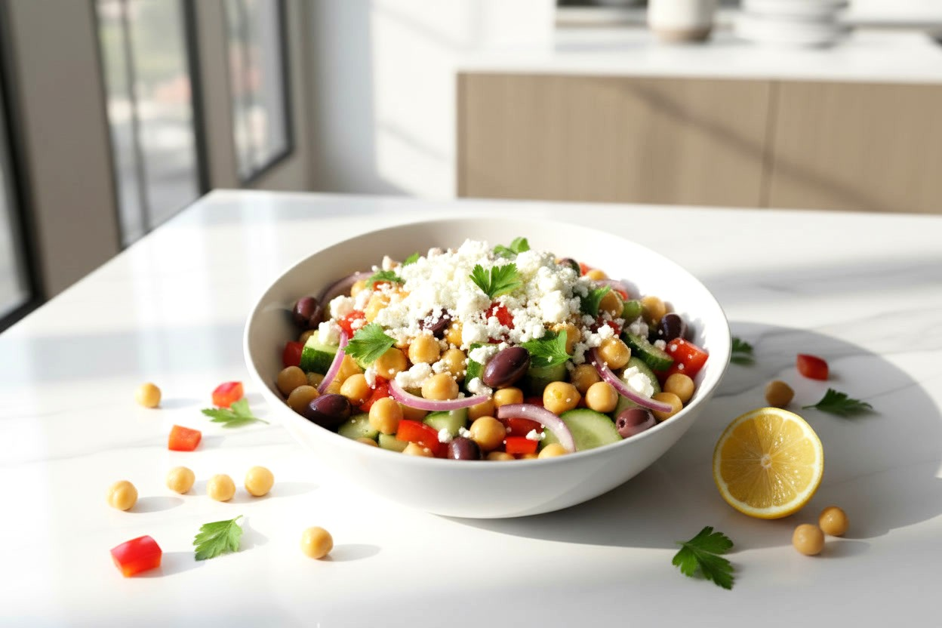

Recipe 3: The "Big Greek" Chickpea Salad
Serves: 1 large main-course bowl | Prep: 10 min | Cook: 0 min
Chef’s Note: This salad is all about the "Crunch Factor." After the soup phase, eating raw, crunchy vegetables triggers satiety signals in the brain faster. We marinate the onions in the lemon juice first—a chef's trick to remove the harsh raw bite while keeping the flavor.
Ingredients:
- 1/2 can (3/4 cup or 130g) chickpeas, rinsed and drained well
- 1/2 cucumber, diced (keep the skin on for fiber)
- 1/2 red bell pepper, diced
- 1/4 red onion, finely sliced or chopped
- 1/4 cup (40g) feta cheese (or vegan feta), crumbled
- 6-8 Kalamata olives, pitted and sliced
- 1 handful fresh parsley, chopped
The Dressing:
- 1 tbsp extra virgin olive oil
- 1 tbsp fresh lemon juice
- 1 tsp dried oregano
- 1/4 tsp sea salt
- 1/4 tsp black pepper
Instructions:
- Mellow the Onions: In the bottom of your salad bowl (or a small jar), combine the lemon juice, red onion, and 1/4 tsp salt. Let this sit for 2–3 minutes while you chop the other vegetables.
- Whisk: Add the olive oil, dried oregano, and black pepper to the onions and whisk/stir to create the dressing.
- The Crunch: Add the chickpeas, cucumber, bell pepper, olives, and parsley to the bowl.
- Toss: Mix everything well so the chickpeas are coated in the dressing.
- Finish: Top with the crumbled feta cheese.
  - Chef's Tip: If taking this to work, put the dressing and onions at the bottom of the jar, chickpeas in the middle, and leafy herbs/feta at the top. Shake before eating.
Nutrition Facts (Per Bowl) (Calculated with 1/2 can Chickpeas and 1/4 cup Feta)
- Calories: ~380
- Carbs: 32g | Fiber: 10g | Protein: 14g | Fat: 22g
Key Benefit: This is a true “Hunger Crusher.” With 10g of fiber and healthy fats from the olives and feta, this meal stabilizes your blood sugar and fills you up, reducing afternoon sugar cravings.
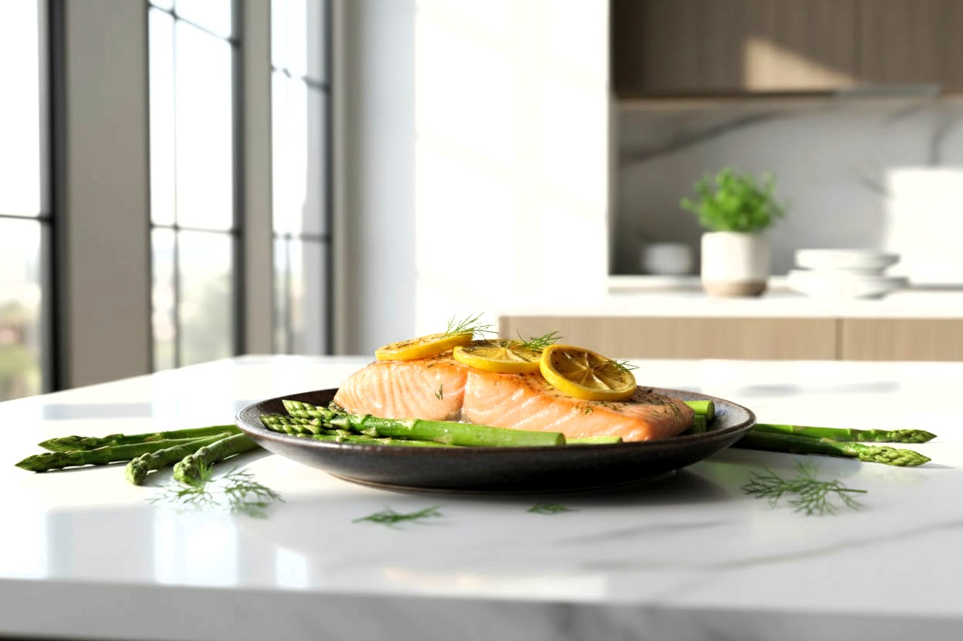

Recipe 4: One-Pan Roasted Salmon & Asparagus
Serves: 1 person | Prep: 5 min | Cook: 12-15 min
Chef’s Note: By roasting the fish and vegetables together, the asparagus absorbs the savory juices from the salmon. We use lemon slices directly on the fish to keep it moist and infuse flavor without adding calories.
Ingredients:
- 1 salmon fillet (approx. 5-6 oz or 150g), skin-on or off
- 1/2 bunch (approx. 150g) asparagus spears, woody ends trimmed
- 1 tbsp extra virgin olive oil
- 1 clove garlic, minced
- 1/2 lemon (cut into 2-3 thin slices, reserve the rest for squeezing)
- 1/2 tsp dried dill or oregano
- 1/4 tsp sea salt
- 1/4 tsp black pepper
Instructions:
- Preheat: Preheat your oven to 400°F (200°C). Line a baking sheet with parchment paper for easy cleanup.
- The Bed: Place the asparagus spears on the baking sheet. Drizzle with half of the olive oil, half the garlic, and a pinch of salt and pepper. Toss with your hands to coat, then spread them out in a single layer to make a "bed" for the salmon.
- The Salmon: Place the salmon fillet right in the center of the asparagus (or next to it). Rub the top with the remaining olive oil, garlic, dill/oregano, salt, and pepper.
- Protect: Lay the lemon slices directly on top of the salmon fillet.
  - Chef's Tip: This acts as a shield against the intense heat, steaming the fish gently while roasting so it stays buttery.
- Roast: Bake for 12–15 minutes. The salmon is done when it flakes easily with a fork, and the asparagus should be tender-crisp (not mushy).
- Serve: Transfer to a plate. Squeeze the remaining fresh lemon juice over the asparagus before eating.
Nutrition Facts (Per Serving) (Calculated with 6 oz / 150g salmon & 1 tbsp oil)
- Calories: ~480
- Carbs: 8g | Fiber: 4g | Protein: 35g | Fat: 32g
Key Benefit: This meal is an Omega-3 powerhouse. These essential fatty acids reduce inflammation and improve insulin sensitivity, helping your metabolism shift into high gear after the soup phase.



Recipe 5: Mediterranean Loaded Sweet Potato
Serves: 1 person | Prep: 10 min | Cook: 7 min (Microwave) or 45 min (Oven)
Chef’s Note: This is the "lazy" chef's secret weapon. Sweet potatoes are complex carbohydrates that digest slowly, keeping you full all evening. The tahini dressing replaces sour cream or butter, adding a nutty richness and healthy fats without the cholesterol.
Ingredients:
- 1 medium sweet potato, scrubbed clean
- 1/2 cup (85g) canned chickpeas, rinsed and drained
- 1/4 cup (40g) cucumber, diced
- 1/4 cup (40g) cherry tomatoes, quartered
- 1 tbsp fresh parsley, chopped
The Tahini Drizzle:
- 1 tbsp tahini (sesame paste)
- 1 tbsp fresh lemon juice
- 1 tbsp warm water (to thin)
- 1/4 tsp garlic powder
- pinch of sea salt
Instructions:
- Cook the Potato:
  - Fast Method: Poke holes all over the sweet potato with a fork. Place on a plate and microwave on High for 5–7 minutes, flipping halfway through, until a knife slides through the center easily.
  - Slow Method (Better Flavor): Bake at 400°F (200°C) for 45 minutes until the skin is crispy and the inside is soft.
- The Filling: While the potato cooks, combine the chickpeas, cucumber, cherry tomatoes, and parsley in a small bowl. Squeeze a little extra lemon juice over them.
- The Sauce: In a small cup, whisk together the tahini, lemon juice, garlic powder, and salt. It might thicken up ("seize") at first—this is normal! Add the 1 tbsp warm water and whisk until it becomes a pourable, creamy sauce.
- Assemble: Slice the cooked sweet potato open lengthwise (don't cut all the way through). Use a fork to fluff up the orange flesh inside.
- Load it Up: Stuff the chickpea salad generously into the opening of the potato.
- Serve: Drizzle the creamy tahini sauce over the whole dish.
Nutrition Facts (Per Loaded Potato) (Calculated with 1 medium potato, 1/2 cup chickpeas, 1 tbsp Tahini)
- Calories: ~360
- Carbs: 58g | Fiber: 12g | Protein: 12g | Fat: 10g
Key Benefit: With 12g of fiber, this meal supports gut health and digestion. The Vitamin A in the sweet potato supports immune function, while the chickpeas provide steady plant-based protein.

Mediterranean Phase Shopping List (2-Week Supply)

This list covers all ingredients needed to transition to solid Mediterranean meals using the 5 recipes provided.
Fresh Produce
- Berries: 4–5 punnets/containers (Mix of Raspberries, Blueberries, Strawberries).
  - Chef’s Tip: Buy 2 fresh packs for Week 1, and 2 bags of Frozen Berries for Week 2 to prevent spoilage.
- Spinach: 1 large bag or tub.
- Asparagus: 3–4 bunches.
- Sweet Potatoes: 4–6 medium.
- Cucumbers: 3–4 large.
- Cherry Tomatoes: 3–4 pints/containers.
- Red Bell Peppers: 3–4 large.
- Red Onion: 2 medium.
- Garlic: 2 bulbs.
- Lemons: 6–8.
- Fresh Herbs:
  - Parsley: 2 bunches.
  - Basil: 1 bunch (Optional for Scramble).
Refrigerated / Protein
- Greek Yogurt (Full-Fat, Unsweetened): 2–3 Large Tubs (approx. 32oz / 900g each).
  - Vegan Option: Unsweetened Coconut, Soya or Almond Yogurt.
- Firm or Extra Firm Tofu: 3–4 blocks (14oz / 400g each).
- Salmon Fillets: 4–6 fillets (5-6oz / 150g each).
  - Storage Tip: Buy 2 fresh for immediate use and 4 frozen fillets for later in the week/Week 2.
- Feta Cheese: 1 block or tub (approx. 7oz / 200g).
Pantry Essentials
- Canned Chickpeas: 6–8 cans (15 oz / 400g).
- Kalamata Olives: 1 large jar (pitted).
- Extra Virgin Olive Oil: 1 large bottle (Replenish if low from Soup Phase).
- Tahini (Sesame Paste): 1 jar.
- Nutritional Yeast: 1 bag/canister.
- Raw Honey: 1 small jar (Optional).
Nuts & Seeds
- Walnuts: 1 bag (approx. 8oz / 200g).
- Hemp Hearts: 1 bag (approx. 8oz / 200g).
- Chia Seeds: 1 bag.
Spices & Seasonings
- Sea Salt: (Pink Himalayan or flaky sea salt, iodised)
- Black Peppercorns: (with a grinder)
- Cinnamon
- Turmeric Powder
- Garlic Powder
- Dried Oregano
- Dried Dill (Optional)
Beverages (Optional)
- Herbal teas: Green tea, Ginger tea, Hibiscus tea, etc.
- Black coffee
- Filtered water
- Mineral water
- Sparkling Water

Part 3: Metabolism-Boosting Yogurts & Teas


The Super Weight-Loss Tea: Nature's "Ozempic"

I call it "Nature's Ozempic" because its effects on cravings and weight loss remind me of what people describe with that expensive medication, but without the hefty price tag or side effects.
Here's the recipe that works wonders:
- 1 cup of brewed green tea (hot)
- 1/2 teaspoon cinnamon
- 1/2 teaspoon turmeric
- 1/2 teaspoon fenugreek powder
- A pinch of black pepper
- A pinch of cayenne powder
- 1 teaspoon prebiotic fiber (inulin or psyllium husk powder)
- 1/2 teaspoon MCT oil
- Healthy sweetener to taste (allulose, monk fruit, or stevia)
Mix everything in the hot tea, let it steep for a few minutes, and drink it throughout the day.
Each ingredient plays a specific role:
The cinnamon helps regulate blood sugar, preventing those crashes that lead to cravings.
Turmeric contains curcumin, a compound with powerful anti-inflammatory properties that also helps with fat metabolism. The black pepper increases curcumin absorption by up to 2,000%! Without it, you'd miss most of turmeric's benefits.
Fenugreek is perhaps the unsung hero here. Research shows it can reduce fat intake and increase feelings of fullness. When combined with cayenne, which boosts metabolism through a process called thermogenesis, you've got a powerful craving-busting, fat-burning duo.
The prebiotic fiber feeds your gut's beneficial bacteria while the MCT oil provides quick energy and helps keep you satisfied.



Morning Wake-Up Drink

Serves: 1 glass | Prep: 1 min
The essential first step of your day. This simple ritual rehydrates your body, kickstarts digestion, and sets your metabolism for the day ahead.
Ingredients:
- 1 cup (240ml) lukewarm water
- 1 tsp lemon juice or apple cider vinegar (prepares digestion)
- 1 tsp prebiotic fiber (inulin or psyllium husk powder)
- a pinch of pink himalayan or sea salt (replenishes electrolytes)
Instructions:
- Stir all ingredients together in a glass of warm water until dissolved.
- Drink immediately upon waking, before coffee or food.
- Wait 15–20 minutes before your first meal or coffee for maximum benefit.


The Yogurt Connection: Gasseri For The Win

Now, let's talk about something equally amazing but often overlooked: probiotic yogurt, specifically Lactobacillus gasseri yogurt.
Compelling studies demonstrate the power of gasseri. Participants consuming it reduced their waist size by about one inch in three months, with no changes to diet or exercise. Beyond this, it can also alleviate symptoms of irritable bowel syndrome and decrease blood and urinary oxalate levels, helping prevent kidney stones.
What's fascinating about gasseri is how it seems to specifically target belly fat and help regulate hunger hormones. And making it at home is surprisingly simple
Ingredients:
1 quart (about 1 liter) of full-fat organic milk, or half-and-half for richer yogurt.
2 tablespoons inulin powder.
2 capsules of Lactobacillus gasseri or 2 tablespoons of previous batch yogurt.

Instructions:
- In a cup, add inulin, bacteria cultures, and a bit of milk.
- Stir to make a paste.
- Add to the yogurt maker, pour in 1 quart (1 liter) of milk, and mix them with a spoon or whisk (electric mixer decimates bacteria).
- Set the temperature to 100°F (38°C) and the timer for 36 hours.
Why 36 hours?
Because helpful bacteria plateau after that. If you forget to take milk from the fridge in advance, no problem at all; just add one hour to the fermentation time—37 hours.
After yogurt is done: Refrigerate in an airtight container, and have about 3.5 ounces (100 ml) in the evenings, or while finishing dinner.
Save a couple of tablespoons of yogurt in a small airtight container in the freezer for a new batch.
Important: If milk is unpasteurized, it needs to be boiled for a few minutes first. Let it cool to 104°F (40°C) or room temperature before adding probiotic cultures. Although unpasteurized milk has beneficial bacteria, too, it also might have Salmonella, E. coli, Listeria, and others. It’s better to play it safe and boil the milk, or buy pasteurized milk.



Probiotic Mineral Water
1 quart (about 1 liter) of still mineral water
1 tsp of organic honey
2 tablespoons inulin powder
1 teaspoon sea salt or Himalayan salt (to taste; it enhances the flavor and helps beneficial bacteria grow). Use natural, without anti-caking agents. Noniodized; although salt with iodine is very good to use with food, it can inhibit bacteria's growth in fermentation.
2 capsules of Lactobacillus gasseri or a cup of previous batch probiotic water.
Instructions:
- Bring water to a boil and let it cool down to room temperature. This prevents unwanted bacteria in your fermented water.
- In a cup, add inulin, bacteria cultures, and a bit of water.
- Stir to make a paste.
- Add the ingredients to the yogurt maker, pour in 1 quart (about 1 liter) of water, add honey and salt, and mix it all together.
- Set the temperature to 100°F (38°C) and the timer for 72 hours.
Save one cup of water as a starter for a new batch.


The Simple Weight-Loss Elixir with Vinegar or Lemon/Lime

This simple drink can reduce your post-meal glucose spike by 20 to 35%, helping accelerate weight loss while curbing those persistent cravings.
The Method: Consume 1 tablespoon of apple cider vinegar (or fresh lemon/lime juice) in 8 ounces (240ml) of water before your main meals.
That's it. Beautifully simple, powerfully effective.
Aim for up to 2 tablespoons total per day. This creates a natural rhythm that supports stable energy throughout your most challenging mealtimes.
Your Choice: Vinegar or Citrus?
Both options deliver extraordinary benefits through different pathways, but they lead to the same destination—significantly blunted blood sugar spikes that support your weight loss journey.
Choose the one that appeals to you most, or—for maximum benefit—alternate between them throughout the week. Both offer remarkably similar effects, so let your taste preferences guide you.
Apple cider vinegar works by slowing gastric emptying and improving insulin sensitivity. The acetic acid helps your muscles absorb glucose more efficiently, leaving less to be stored as fat. Choose unsweetened, raw, unfiltered apple cider vinegar with "the mother"—those wispy strands that contain beneficial enzymes and probiotics. Look for a 5% acidity solution, which provides optimal potency without being overly harsh.
Lemon or lime juice contains citric acid, which inhibits carbohydrate-digesting enzymes, essentially slowing down how quickly sugars enter your bloodstream. It also provides Vitamin C and delivers specific polyphenols that function like 'prebiotic' fuel. These compounds feed beneficial gut bacteria, which in turn produce strengthening signals that train your immune system to lower inflammation and activate your body’s own built-in anti-aging defenses.
Smart Safety Practices
- Always dilute properly: 1 tablespoon per 8 ounces (240ml) of water
- Sip through a straw to minimize enamel contact
- Rinse your mouth with plain cold water afterward
- Wait 30-60 minutes before brushing your teeth (the acid temporarily softens enamel)
Important
This powerful tool isn't suitable for everyone. Please consult your healthcare provider before starting if you have any of the following:
- Stomach ulcers or chronic gastritis
- Acid reflux or heartburn
- Chronic kidney disease
- You take diabetes or diuretic medications (as their effects may be enhanced)
- Any other health condition that could be worsened by acidic drinks.


Herbal Powerhouses: Hibiscus, Ginger, and Fenugreek Teas

Hibiscus tea has been shown in studies to inhibit carbohydrate-digesting enzymes, potentially preventing some carb absorption while reducing inflammation.
Ginger tea is my evening comfort. Besides reducing inflammation, it helps with digestion and has been shown to enhance thermogenesis—literally helping your body burn more calories while processing food.
Fenugreek tea deserves special mention for its ability to stabilize blood sugar and reduce cravings specifically for sweet foods. When I'm having a day where sugar cravings feel overwhelming, this is my immediate response.
These powerful beverages are science in a delicious disguise. They work with your body's natural mechanisms to regulate appetite, boost metabolism, and support healthy digestion.
Simple Preparation Guide
Hibiscus (The Carb Blocker): Steep a bag or 1 tsp dried flowers in 8 oz (240ml) hot water for 5–7 minutes. Add a squeeze of lime or a drop of stevia/allulose if it’s too tart. Best time: 20 minutes before a carb-heavy meal.
Ginger (The Metabolic Fire): Slice 1 inch (2.5cm) of fresh ginger root (or use a high-quality bag) and steep in 8 oz (240ml) boiling water for 10 minutes. Add lemon juice for an extra detox boost. Best time: After dinner to aid digestion and prevent late snacking.
Fenugreek (The Craving Killer): Steep 1 tsp of seeds/powder or a tea bag in 8 oz (240ml) hot water for 5–10 minutes. It has a maple-like scent. Best time: Immediately when a sugar craving strikes.
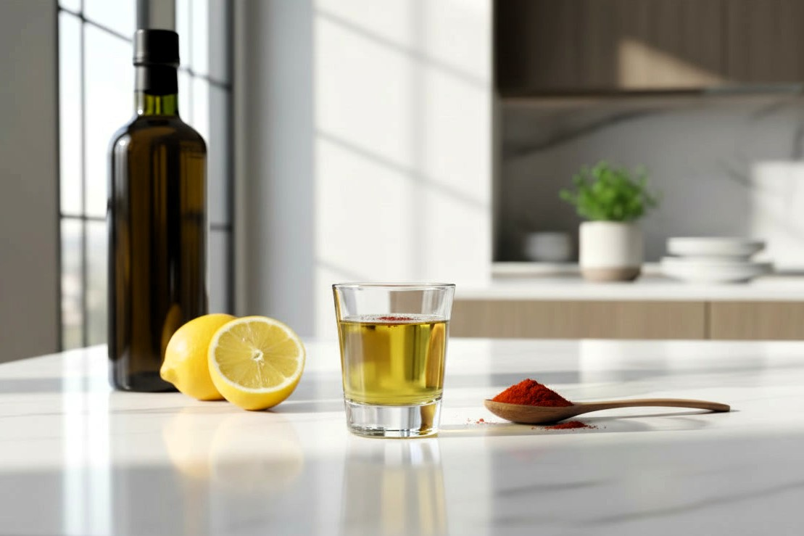

The Satiety Shot: A Pre-Meal Secret Weapon

One of my most effective discoveries combines several of these natural craving fighters into what I call the "Satiety Shot"—a simple pre-meal drink that dramatically reduces hunger and prevents post-meal cravings.
Here's the formula:
- 1 tablespoon extra virgin olive oil
- 1 teaspoon lemon or lime juice
- A small pinch of cayenne pepper
Take this combination about 20 minutes before meals. The healthy fats in olive oil trigger the release of cholecystokinin (CCK), a powerful satiety hormone. The acidity of lemon juice slows gastric emptying, helping you feel fuller longer. And the cayenne, as mentioned, supports metabolism while reducing appetite.

Supplements at a Glance

Metabolic Accelerators & Fat Burners
These supplements are chosen specifically to support insulin sensitivity, boost metabolism, and manage hunger.
Supplement | Dosage | When to Take | Key Benefit | Important Notes
Berberine | 500mg, 3x daily | 15–20 min before meals | Activates AMPK (the "metabolic master switch"); improves insulin sensitivity. | Consult your doctor if you take blood pressure or diabetes meds. Not for pregnancy/nursing.
MCT Oil | Start: 1/2 tsp per day, then slowly increase to 1 tsp per meal  Max: 2–3 tbsp per day | With meals (avoid taking on an empty stomach) | Converts directly to ketones for immediate energy; burns ~120 extra cal/day; mental clarity. | Start slowly to avoid digestive upset. Choose pure C8 (or mixed with C10, but not C12). Do not cook with it.
Extra Virgin Olive Oil | 1 tbsp per meal | With each meal | Prevents gallstones during rapid weight loss; preserves muscle; enhances satiety. | Choose cold-pressed EVOO. It is safe for cooking.
Prebiotic Fiber | Start: 1 tsp daily  Goal: Up to 2 tbsp daily | Morning ritual and mixed into drinks or meals | Feeds beneficial gut bacteria; blunts blood sugar spikes; reduces hunger. | Options: Inulin powder, Psyllium Husk, or soaked Basil Seeds. Increase slowly to avoid bloating.
B-Complex | 1 capsule daily | Morning or early afternoon | Supports energy metabolism; helps convert food into fuel rather than fat. | Choose methylated (activated) forms (Methylfolate, Methylcobalamin) for best absorption. Take separately from Vitamin C.

Quality Checklist
Third-Party Tested: Look for USP, NSF, or ConsumerLab certifications to ensure potency.
No Fillers: Avoid brands using rice flour, maltodextrin, or artificial colors.
Bioavailability: Always choose "activated" vitamins (e.g., P5P for B6, Methylfolate for B9) when available.

Foundation, Repair & Structure

These nutrients are critical for preventing side effects (like cramps or loose skin), supporting sleep, and maintaining structural health as you lose weight.
Supplement | Dosage | When to Take | Key Benefit | Important Notes
Vitamin D3 | 4,000 IU daily (or as recommended by your doctor) | Morning, with a meal containing fat | Supports metabolism, insulin function, gut health, and mood. | Most people are deficient. Fat-soluble (must take with food). Always pair with K2.
Vitamin K2 (MK7) | 200 mcg daily | With Vitamin D3 | Directs calcium into bones and away from arteries; essential partner to D3. | Crucial for heart and bone health. Often found in combo pills with D3.
Magnesium | 800mg daily (Split dose) | Dose 1: Afternoon  Dose 2: Before Bed | Promotes deep sleep, relaxation, and muscle recovery; prevents leg cramps. | Choose Glycinate or Citrate forms. Consult your doctor if you have kidney disease.
Potassium | 2,000–3,000mg daily | With meals throughout the day | Balances fluids; prevents fatigue and muscle cramps; supports blood pressure. | Obtain from food (avocados, leafy greens) + supplements. Caution with kidney disease/meds.
Vitamin C | 2,000mg daily (Split dose) | Dose 1: Morning  Dose 2: Afternoon | Essential for collagen production (skin elasticity); reduces inflammation; boosts immunity. | Choose Time-Release if possible. Take separately from B12 for better absorption.

Your Daily Supplement Timeline

Morning (Wake Up)
- Water + Prebiotics + Salt + Lemon
- Vitamin D3 + K2 (with breakfast/fat)
- B-Complex
- Vitamin C (Dose 1)
Before Main Meals
- Berberine (15-20 mins prior)
- Vinegar/Citrus "Slimming Elixir"
During Meals
- Extra Virgin Olive Oil
- MCT Oil
- Potassium
Afternoon
- Magnesium (Dose 1)
- Vitamin C (Dose 2)
Evening / Bedtime
- Magnesium (Dose 2 - for sleep)

Important: Supplements complement—but never replace—a nutrient-dense diet. The dosages listed here are based on general research. Always consult your healthcare provider before starting any new supplement regimen, especially if you have medical conditions, kidney issues, or take prescription medications.

Simple Moves to Accelerate Fat Loss
Studies show that just 10 minutes of light exercise within the two-hour window after eating can significantly reduce the amount of glucose being converted to fat. The muscle contractions during exercise act like a sponge, soaking up glucose from your bloodstream and using it as immediate energy instead of allowing it to be stored.
You don't need intense workouts to see benefits. Simple activities like a short walk, gentle stretching, or even standing instead of sitting can make a meaningful difference. My personal favorite, especially when I can't get outside after a meal, is the humble heel raise.
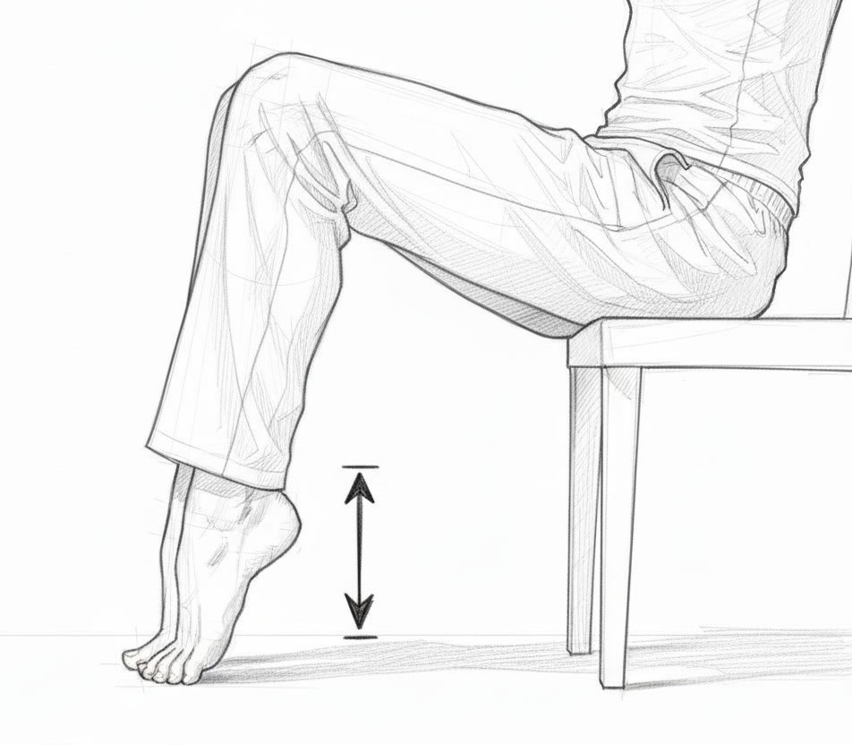
The "Anytime" Heel Raise
Heel raises can be done anywhere—while browsing on your phone, working, or watching TV. While sitting, rise up onto the balls of your feet (lift your heels), hold briefly, then lower back down. Repeat this movement for a few minutes, and you're activating large muscle groups in your legs that efficiently pull glucose from your bloodstream.
As an added benefit, regular heel raises strengthen your calf muscles and support your foot's arch structure, which can reduce stress on your knees by improving how your body absorbs walking or running impact. It's particularly helpful if you're dealing with joint discomfort or osteoarthritis.

Make Every Tooth-Brushing Count
Finding it hard to exercise on busy days? Use your daily tooth-brushing time! It's a perfect chance to move a bit more. These two simple exercises don't take any longer but do great things for your health.


Balance Builder (Tandem Stance)
While brushing your teeth, try standing with one foot directly in front of the other, like you're walking on an imaginary line. Your front foot's heel should touch your back foot's toe. Hold this position for 30 seconds, then switch feet.
Why this helps you:
This simple balance exercise strengthens your core muscles and improves your stability. It helps your body become more aware of its position, enhancing coordination between your brain and muscles. For older adults, it's especially valuable as it reduces fall risks and builds confidence for everyday activities.
Your balance improves, your posture gets better, and even your brain gets a workout! The muscles around your ankles, knees, and hips become stronger, providing better support for your joints.



The "King" of Exercises - Simple Squats
Stand tall with your feet shoulder-width apart while brushing. Keep your chest up and eyes forward. Gently lower your body as if sitting back into a chair, keeping your back straight. Go only as low as feels comfortable, then rise back up through your heels.
What makes this so powerful:
Squats work all the major muscles in your lower body—your thighs, hamstrings, and buttocks. They engage your core, improve your mobility, and help strengthen your bones. Even small "baby squats" provide benefits if your knees are sensitive.
This exercise helps with everyday movements like sitting and standing, burns calories, and can prevent injuries by strengthening the muscles that support your joints.
By adding these simple exercises to your tooth-brushing routine, you're making a smart investment in your health without spending any extra time in your day. Imagine how much stronger and more stable you could feel after a few weeks of this simple habit!
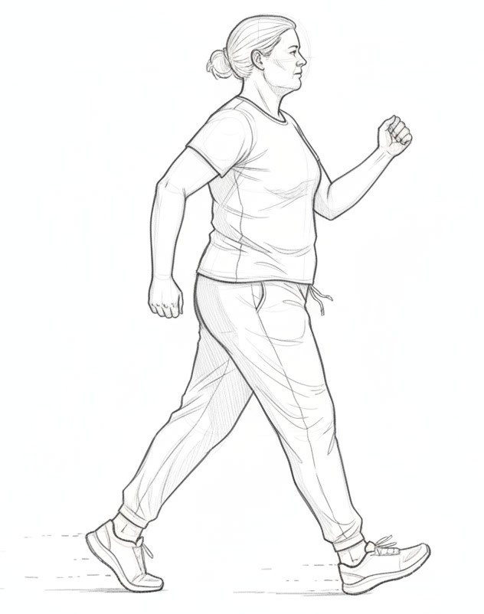

Walking: Your Simple Path to Weight Loss
Walking is a fantastic and accessible tool for improving your health and managing weight.
What makes walking particularly effective is its sustainability. Unlike high-intensity exercises that might quickly lead to burnout, walking can be maintained for longer periods, leading to steady calorie burning. A brisk 30-minute walk can burn between 100 to 300 calories depending on your pace and weight, and when done consistently, this creates the calorie deficit necessary for weight loss.
Beyond weight management, walking triggers a cascade of health benefits throughout your body. Your cardiovascular system strengthens as your heart pumps more efficiently. Your muscles become more toned, your balance improves, and your joints remain lubricated and healthy. Perhaps most remarkably, walking stimulates the release of endorphins—your body's natural mood elevators—creating a positive feedback loop that encourages you to continue this healthy habit.
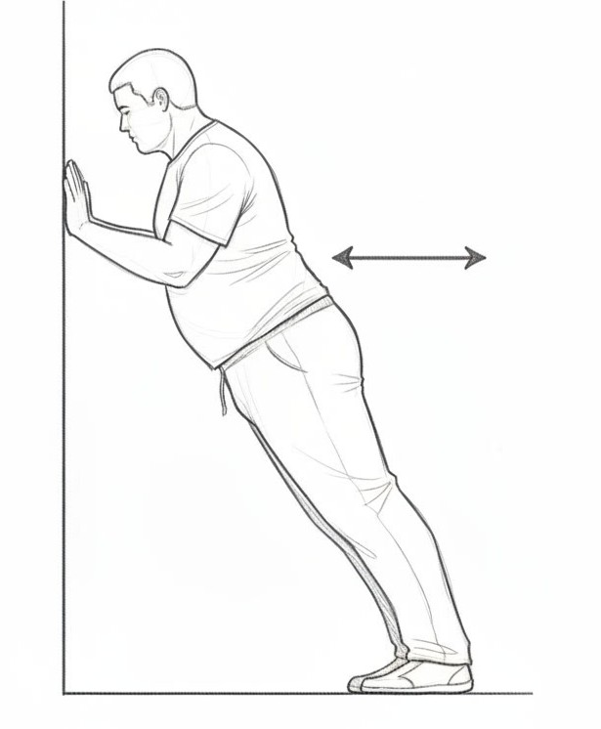

Wall Push-Ups: Your Gentle Start to Strength
Stand at arm's length from a wall. Place your hands flat against the wall at chest level. Bend your arms, leaning toward the wall, then push back.
Perfecting Your Form: Keep your body in a straight line from head to heels – don't let your hips sag or stick out. Engage your core. Keep your elbows slightly tucked toward your body as you bend them, rather than flaring them straight out to the sides. Move slowly and with control.
Wall push-ups are a great starting point for building upper body strength, especially if regular push-ups feel too challenging or if you have concerns about your joints.
Muscles Worked: They primarily strengthen your chest muscles (pectorals), the front of your shoulders (anterior deltoids), and the back of your arms (triceps). Your core muscles also work gently to keep your body stable and straight.
Why They're Great (Especially for Seniors/Overweight Individuals):
- Low Impact: Very gentle on wrists, elbows, and shoulders compared to floor push-ups.
- Adjustable: You control the difficulty! Stand closer to the wall to make it easier, or step further back (keeping your body straight) to increase the challenge.
- Functional Strength: Builds the strength needed for everyday activities like pushing doors, getting up from a chair, or carrying groceries.

Tracking Tools & Progress Worksheets
These tools will help you track your progress, identify patterns, and celebrate your victories along the way.
Download Your Printable Worksheets. To make the most of this program, I have created print-ready PDF and Word versions of these logs for you. Download them here: https://damodara.co.uk/resources

Print these pages and keep them visible where you'll see them daily—on your refrigerator, bathroom mirror, or workspace.

Goal Setting & Vision
Clarify your 'why' and visualize your success. Review this page regularly to stay motivated.
My Ultimate Goal Weight: __________ lbs/kg
My "Weight Trigger Point" (Goal + 5lbs): __________ lbs/kg
Target Date: __________________
Why is this important to me? (Be specific and emotional):
_________________________________________________________________
_________________________________________________________________
_________________________________________________________________
_________________________________________________________________
How will I feel when I achieve this goal?
_________________________________________________________________
_________________________________________________________________
_________________________________________________________________
What will I be able to do that I can't do now?
_________________________________________________________________
_________________________________________________________________
_________________________________________________________________
My Support Team (people I can count on):
_________________________________________________________________
_________________________________________________________________
My commitment to myself:
I, __________________________, commit to following this program for the next three months. I will honor my body, trust the process, and celebrate every victory along the way. I am shifting my identity from "someone on a diet" to "someone who lives a healthy life."

Signature: _____________________________ Date: ____________

Your Starting Point
Record your baseline measurements on Day 1. This is your 'before' snapshot.
Measurement | Day 1 (Starting)
Date: | _________________
Weight: | _________ lbs / kg
Chest: | _________ inches / cm
Waist (at belly button): | _________ inches / cm
Hips: | _________ inches / cm
Thighs (Left / Right): | _____/_____ inches / cm
Arms (Left / Right): | _____/_____ inches / cm
Photos taken: | ☐ Front ☐ Side ☐ Back
How I Feel Today:
_________________________________________________________________
_________________________________________________________________
_________________________________________________________________
_________________________________________________________________
_________________________________________________________________
_________________________________________________________________
_________________________________________________________________
_________________________________________________________________

12-Week Weight Tracking Chart
Weigh yourself once per week, same day, same time, wearing similar clothing.
Week | Phase (Soup/Med) | Date | Weight | Change
1
2
3
4
5
6
7
8
9
10
11
12
Total Weight Lost in 12 Weeks: __________ lbs / kg

Monthly Measurements Tracker
Take full body measurements once per month to track changes the scale might not show.
Body Part | Month 1 | Month 2 | Month 3
Chest
Waist
Hips
Left Thigh
Right Thigh
Left Arm
Right Arm

Daily Progress Journal
Date: ____________ Day #: _____ Phase: ☐ Soup Blitz ☐ Mediterranean
Fasting Window
- Fast Started (Yesterday): _______ AM/PM
- Fast Broken (Today): _______ AM/PM
- Total Fasting Hours: _______ hours
Morning Ritual ☐ Water + Lemon/Vinegar + Prebiotics + Pinch of Salt
☐ Morning Sunlight (10-15 mins)
The Daily Supplements: ☐ MCT Oil (1/2 tsp to 3 tsp per day) ☐ Berberine (Before meals)
☐ Vitamins (C, D3, K2, B-Complex) ☐ Electrolytes (Magnesium/Potassium)
☐ Olive Oil (1 tbsp with each meal) ☐ Other_______________________
Meals & Food Order
Veggies First → Protein/Fats → Carbs Last
Meal 1: _________________________________________________
- Hunger Scale (Start): ___/10 (Aim for 3-4)
- Satiety Scale (End): ___/10 (Aim for 6-7)
- Protocol Check: ☐ Vinegar/Satiety Shot?
- Movement: ☐ 10-min walk/exercises after eating?
Meal 2: _________________________________________________
- Hunger Scale (Start): ___/10
- Satiety Scale (End): ___/10
- Protocol Check: ☐ Vinegar/Satiety Shot?
- Movement: ☐ 10-min walk/exercises after eating?
Light 3rd Meal or Snack (Optional): ____________________
Hydration (Aim for 8-10 glasses): ☐ ☐ ☐ ☐ ☐ ☐ ☐ ☐ ☐ ☐
Daily Reflection
- Energy Level (1-10): _____
- Mood/Emotions (1-10): _____
- Challenges Today (Triggers/Cravings):_____________________________
- Non-Scale Victory: _____________________________________________
- Tomorrow's Plan: ______________________________________________

Non-Scale Victories Tracker
The scale doesn't tell the whole story! Track these important wins that show your body is transforming:
- ☐ Clothes fitting looser or dropping a size
- ☐ Increased energy throughout the day
- ☐ Reduced cravings for sugar/processed foods
- ☐ Better sleep quality
- ☐ Clearer skin
- ☐ Improved digestion
- ☐ More confidence
- ☐ Climbing stairs without getting winded
- ☐ Compliments from friends/family
- ☐ Better mood/reduced anxiety
- ☐ Stronger physically
- ☐ Taste bud reset (Natural food tastes sweeter)
- ☐ Reduced inflammation/joint pain (Gluten/Lectin reduction)
- ☐ Clearer thinking/better focus
- ☐ Wedding ring/jewelry fits better
- ☐ Face looks slimmer/more defined
Other victories:
_________________________________________________________________
_________________________________________________________________
_________________________________________________________________
_________________________________________________________________
Every positive change, no matter how small, is worth celebrating!

Join Our Community
While this audiobook and companion PDF give you all the knowledge and tools you need to succeed, real lasting change is easier when you're not going it alone. That's why I've created a private community specifically for people following the Slim in Record Time program.
- Stay Inspired & Motivated: Get fresh ideas, new recipes, and the encouragement you need when your motivation naturally ebbs and flows
- Get Your Questions Answered: Direct access to me for personalized guidance and support
- Connect with Others: Join a friendly group of people on the exact same path who understand your challenges and celebrate your wins
- Ongoing Support: Weekly tips, and continuous learning to keep you on track for life
- Real Success Stories: Be inspired by others who've transformed their bodies and lives using this exact program
How to Join
Visit our community website to learn more and become part of our supportive family at slimtogether.net
On the website, you'll find:
- Detailed information about membership benefits
- Current pricing and membership options
- Success stories from community members
- Easy enrollment process
- Frequently asked questions
This audiobook has given you the knowledge and the tools. The community offers the ongoing support to make it last a lifetime.
When you're ready to lock in your success and ensure you never have to go it alone, I'll be there waiting to welcome you. Let's continue this journey together!
Stay Connected
Have questions or want to share your success story? I'd love to hear from you!
Email: info@slimtogether.net

Scientific References
This program is grounded in scientific research. Below are the key studies and resources that inform the recommendations in this book.
Chapter 2: Why Everything You've Tried Has Failed You (Not the Other Way Around)
- Lopes SM, Francisco MG, Higashi B, et al. Ten-week sucralose consumption induces gut dysbiosis and altered glucose and insulin levels in healthy young adults. Front Nutr. 2022; 9: 848392.
https://pmc.ncbi.nlm.nih.gov/articles/PMC8880058/
- Hosseini A, Barlow GM, Leite G, Rashid M, Parodi G, Wang J, Morales W, Weitsman S, Rezaie A, Pimentel M, Mathur R. Consuming artificial sweeteners may alter the structure and function of duodenal microbial communities. iScience. 2023; 26(12): 108530. doi: 10.1016/j.isci.2023.108530
https://pmc.ncbi.nlm.nih.gov/articles/PMC10730370/
- Pepino MY, Tiemann CD, Patterson BW, Wice BM, Klein S. Sucralose affects glycemic and hormonal responses to an oral glucose load. Diabetes Care. 2013; 36(9): 2530-2535.
https://doi.org/10.2337/dc12-2221
- Di Rienzi, S. C., & Ely, B. K. Sucralose: From Sweet Success to Metabolic Controversies—Unraveling the Global Health Implications of a Pervasive Non-Caloric Artificial Sweetener. Life (Basel). 2024; 14(3): 323.
https://www.mdpi.com/2075-1729/14/3/323
- Lustig, R. H. Fat Chance: Beating the Odds Against Sugar, Processed Food, Obesity, and Disease. New York: Hudson Street Press; 2013.
- SugarScience UCSF. Hidden in Plain Sight. SugarScience. https://sugarscience.ucsf.edu/hidden-in-plain-sight/
- Dighe, S., et al. Fructose Metabolism. In: StatPearls. StatPearls Publishing; 2024. https://www.ncbi.nlm.nih.gov/books/NBK576428/
- Gugliucci, A. Fructose and NAFLD: The Vicious Circle. Life (Basel). 2020; 11(1): 2.
https://pmc.ncbi.nlm.nih.gov/articles/PMC7774304/
- Jaiswal N, Maurya CK, Arha D, Avisetti DR, Prathapan A, Raj PS, Raghu KG, Kalivendi SV, Tamrakar AK. Fructose induces mitochondrial dysfunction and triggers apoptosis in skeletal muscle cells by provoking oxidative stress. Apoptosis. 2015; 20(7): 930-947. https://link.springer.com/article/10.1007/s10495-015-1128-y
- Encarnação LM, de Oliveira BGP, Carvalho FIF, et al. Ultra-Processed Foods and Food Addiction—A Scoping Review of the Evidence. Nutrients. 2023; 15(12): 2759. https://www.ncbi.nlm.nih.gov/pmc/articles/PMC10260459/
- Freed DL. Do dietary lectins cause disease? The evidence is suggestive—and raises interesting possibilities for treatment. BMJ. 1999; 318 (7190): 1023-1024. https://www.ncbi.nlm.nih.gov/pmc/articles/PMC1115436/
- Kamikubo Y, Dellas C, Loskutoff DJ, Quigley JP, Ruggeri ZM. Contribution of leptin receptor N-linked glycans to leptin binding. Biochem J. 2008; 410(3): 595-604. https://pubmed.ncbi.nlm.nih.gov/17983356/
- Due A, Larsen TM, Mu H, et al. Substitution of saturated with monounsaturated fat in a 4-week diet affects body weight and composition of overweight and obese men. Br J Nutr. 2008; 99(6): 1213-1220.
https://pubmed.ncbi.nlm.nih.gov/13129479/
- Markussen LK, Dalskov SM, Damsgaard CT, et al. Saturated fatty acids in human visceral adipose tissue are associated with increased 11β-hydroxysteroid-dehydrogenase type 1 expression. Lipids Health Dis. 2015; 14: 42. https://pmc.ncbi.nlm.nih.gov/articles/PMC4424543/
- Piers LS, Walker KZ, Stoney RM, Soares MJ, O'Dea K. Substitution of saturated with monounsaturated fat in a 4-week diet affects body weight and composition of overweight and obese men. Br J Nutr. 2003; 90(3): 717-727.
https://doi.org/10.1079/BJN2003948
- Tonstad S, Butler T, Yan R, Fraser GE. Type of vegetarian diet, body weight, and prevalence of type 2 diabetes. Diabetes Care. 2009; 32(5): 791-796.
https://doi.org/10.2337/dc08-1886
Chapter 3: Healthy Fats and Sweeteners Are Amazing for You
- Clevenger HC, Stevenson JL, Cooper JA. Metabolic responses to dietary fatty acids in obese women. Physiology & Behavior. 2015; 139: 73-79.
- Tsai CJ, Leitzmann MF, Willett WC, Giovannucci EL. The Effect of Long-Term Intake of cis Unsaturated Fats on the Risk for Gallstone Disease in Men: A Prospective Cohort Study. Ann Intern Med. 2004; 141(7): 514-522.
https://doi.org/10.7326/0003-4819-141-7-200410050-00003
- De Alzaa F, Guillaume C, Ravetti L. Evaluation of Chemical and Physical Changes in Different Commercial Oils during Heating. Acta Scientific Nutritional Health. 2018; 2(6)
http://olivewellnessinstitute.org/wp-content/uploads/2018/05/Acta-Scientific_Final_Evaluation-of-Chemical-and-Physical-Changes-in-Different-Com.pdf
- De Alzaa F, Guillaume C, Ravetti L. Evaluation of Chemical and Nutritional Changes in Chips, Chicken Nuggets, and Broccoli after Deep-Frying with Extra Virgin Olive Oil, Canola, and Grapeseed Oils. Journal of Food Quality. 2021; 2021: 7319013. https://onlinelibrary.wiley.com/doi/10.1155/2021/7319013
- Velasco J, Dobarganes C. Oxidative stability of virgin olive oil. European Journal of Lipid Science and Technology. 2002; 104(9): 661-676.
- Fullana A, Carbonell-Barrachina ÁA, Sidhu S. Comparison of volatile aldehydes present in the cooking fumes of extra virgin olive, olive, and canola oils. J Agric Food Chem. 2004; 52(16): 5207-5214. doi: 10.1021/jf035241f.
- Markellos C, Ourailidou ME, Gavriatopoulou M, Halvatsiotis P, Sergentanis TN, Psaltopoulou T. Olive oil intake and cancer risk: A systematic review and meta-analysis. PLoS One. 2022; 17(1): e0261649.
https://pmc.ncbi.nlm.nih.gov/articles/PMC8751986/
- Dulloo AG, Fathi M, Mensi N, Girardier L. Twenty-four-hour energy expenditure and urinary catecholamines of humans consuming low-to-moderate amounts of medium-chain triglycerides: a dose-response study in a human respiratory chamber. Eur J Clin Nutr. 1996; 50(3): 152-158.
- Tani Y, Tokuda M, Nishimoto N, Yokoi H, Izumori K. Allulose for the attenuation of postprandial blood glucose levels in healthy humans: A systematic review and meta-analysis. PLoS One. 2023; 18(4): e0281150.
https://doi.org/10.1371/journal.pone.0281150
Chapter 4: Quick Weight Loss Is Better Than Slow
- Nackers LM, Ross KM, Perri MG. The association between rate of initial weight loss and long-term success in obesity treatment: does slow and steady win the race? Int J Behav Med. 2010; 17(3): 161-167.
https://pmc.ncbi.nlm.nih.gov/articles/PMC3780395/
- Hemmingsson E, Johansson K, Eriksson J, Sundström J, Neovius M, Marcus C. Weight loss and dropout during a commercial weight-loss program including a very-low-calorie diet, a low-calorie diet, or restricted normal food: observational cohort study. Am J Clin Nutr. 2012; 96(5): 953-961.
https://pmc.ncbi.nlm.nih.gov/articles/PMC3471207/
- Lean ME, Leslie WS, Barnes AC, Brosnahan N, Thom G, McCombie L, Peters C, Zhyzhneuskaya S, Al-Mrabeh A, Hollingsworth KG, Rodrigues AM, Rehackova L, Adamson AJ, Sniehotta FF, Mathers JC, Ross HM, McIlvenna Y, Stefanetti R, Trenell M, Welsh P, Kean S, Ford I, McConnachie A, Sattar N, Taylor R. Primary care-led weight management for remission of type 2 diabetes (DiRECT): an open-label, cluster-randomised trial. Lancet. 2018; 391(10120): 541-551.
https://doi.org/10.1016/S0140-6736(17)33102-1
- Seimon RV, Wild-Taylor AL, Keating SE, McClintock S, Harper C, Gibson AA, Johnson NA, Fernando HA, Markovic TP, Center JR, Franklin J, Liu PY, Grieve SM, Lagopoulos J, Caterson ID, Byrne NM, Sainsbury A. Effect of Weight Loss via Severe vs Moderate Energy Restriction on Lean Mass and Body Composition Among Postmenopausal Women With Obesity: The TEMPO Diet Randomized Clinical Trial. JAMA Netw Open. 2019; 2(10): e1913733.
https://pmc.ncbi.nlm.nih.gov/articles/PMC6824325/
- Parretti HM, Jebb SA, Johns DJ, Lewis AL, Christian-Brown AM, Aveyard P. Clinical effectiveness of very-low-energy diets in the management of weight loss: a systematic review and meta-analysis of randomized controlled trials. Obes Rev. 2016; 17(3): 225-34. https://pubmed.ncbi.nlm.nih.gov/26775902/
- Ashtary-Larky D, Bagheri R, Abbasnezhad A, Tinsley GM, Alipour M, Wong A. Effects of gradual weight loss v. rapid weight loss on body composition and RMR: a systematic review and meta-analysis. Br J Nutr. 2020; 124(11): 1121-1132. https://pubmed.ncbi.nlm.nih.gov/32576318/
- Wing RR, Lang W, Wadden TA, Safford M, Knowler WC, Bertoni AG, Hill JO, Brancati FL, Peters A, Wagenknecht L; Look AHEAD Research Group. Benefits of Modest Weight Loss in Improving Cardiovascular Risk Factors in Overweight and Obese Individuals With Type 2 Diabetes. Diabetes Care. 2011; 34(7): 1481-1486. https://pmc.ncbi.nlm.nih.gov/articles/PMC3120182/
Chapter 5: The Complete Weight Loss Program
- Poon ETC, Tsang JH, Sun F, Zheng C, Wong SHS. Effects of intermittent dieting with break periods on body composition and metabolic adaptation: a systematic review and meta-analysis. Nutr Rev. 2025; 83(1): 59-71.
https://doi.org/10.1093/nutrit/nuad168
- Mitchell SJ, Bernier M, Mattison JA, Aon MA, Kaiser TA, Anson RM, Ikeno Y, Anderson RM, Ingram DK, de Cabo R. Daily fasting improves health and survival in male mice independent of diet composition and calories. Cell Metab. 2019; 29(1): 221-228.e3. https://www.ncbi.nlm.nih.gov/pmc/articles/PMC6326845/
Chapter 6: The Two-Week Vegan Soup Blitz: Your Rapid Start Phase
- Wansink B, Sobal J. Mindless Eating: The 200 Daily Food Decisions We Overlook. Environment and Behavior. 2007; 39(1): 106-123. https://journals.sagepub.com/doi/10.1177/0013916506295573
- Galgano F, Favati F, Caruso M, Pietrafesa A, Natella S. The Influence of Processing and Preservation on the Retention of Health-Promoting Compounds in Broccoli. Journal of Food Science. 2007; 72(2): S130-S135.
https://doi.org/10.1111/j.1750-3841.2006.00258.x
Chapter 7: Gluten-Free Mediterranean Lifestyle
- Guasch-Ferré M, Willett WC, Hu FB. The Mediterranean diet and health: a comprehensive overview. Journal of Internal Medicine. 2021; 290(3): 549-566. https://onlinelibrary.wiley.com/doi/10.1111/joim.13333
- Zhang X, Xiao D, Guzman G, Edirisinghe I, Burton-Freeman B. Avocado Consumption for 12 Weeks and Cardiometabolic Risk Factors: A Randomized Controlled Trial in Adults with Overweight or Obesity and Insulin Resistance. J Nutr. 2022; 152(8): 1851-1861. https://pubmed.ncbi.nlm.nih.gov/35700149/
- Donohoe DR, Holley D, Collins LB, Montgomery SA, Whitmore AC, Hillhouse A, Curry KP, Renner SW, Greenwalt A, Ryan EP, Godfrey V, Heise MT, Threadgill DW, Han A, Swenberg JA, Cantrell MA, Bultman SJ. A gnotobiotic mouse model demonstrates that dietary fiber protects against colorectal tumorigenesis in a microbiota- and butyrate-dependent manner. Cancer Prev Res. 2014; 7(6): 541-551. https://pmc.ncbi.nlm.nih.gov/articles/PMC3944646/
Chapter 8: The Wheat Paradox: When "Healthy" Foods Make You Heavier
- Dalla Pellegrina C, Perbellini O, Scupoli MT, Tomelleri C, Zanetti C, Zoccatelli G, Fusi M, Peruffo A, Rizzi C, Chignola R. Effects of wheat germ agglutinin on human gastrointestinal epithelium: insights from an experimental model of immune/epithelial cell interaction. Toxicol Appl Pharmacol. 2009; 237(2): 146-153. https://pubmed.ncbi.nlm.nih.gov/19332085/
- Fasano A. Zonulin and its regulation of intestinal barrier function: the biological door to inflammation, autoimmunity, and cancer. Physiol Rev. 2011; 91(1): 151-175. https://journals.physiology.org/doi/full/10.1152/physrev.00003.2008
- Vasconcelos IM, Oliveira JTA. Antinutritional properties of plant lectins. Toxicon. 2004; 44(4): 385-403.
https://doi.org/10.1016/j.toxicon.2004.05.005
- Gundry SR. The Longevity Paradox: How to Die Young at a Ripe Old Age. New York: Harper Wave; 2019.
- Freed DLJ. Do dietary lectins cause disease? The evidence is suggestive—and raises interesting possibilities for treatment. BMJ. 1999; 318(7190): 1023-1024. https://pmc.ncbi.nlm.nih.gov/articles/PMC1115436/
- Livingston JN, Purvis BJ. Effects of wheat germ agglutinin on insulin binding and insulin sensitivity of fat cells. Am J Physiol. 1980; 238(3): E267-E275. https://pubmed.ncbi.nlm.nih.gov/6989266/
- Rajasekaran A, Julian BA, Rizk DV. IgA nephropathy: an interesting autoimmune kidney disease. Heliyon. 2024; 10(20): e39471.
https://www.cell.com/heliyon/fulltext/S2405-8440(24)15502-8
- Kritchevsky D, Tepper SA, Klurfeld DM. Lectin may contribute to the atherogenicity of peanut oil. Lipids. 1998; 33(8): 821-823.
https://pubmed.ncbi.nlm.nih.gov/9727614/
- O'Bryan T. The Heartbreak of Wheat-Related Disorders: Wheat, Gluten and Cardiovascular Disease. In: Sinatra ST, Houston MC, editors. Nutritional and Integrative Strategies in Cardiovascular Medicine. 2nd ed. Boca Raton: CRC Press; 2022. https://www.taylorfrancis.com/chapters/edit/10.1201/9781003137849-11/heartbreak-wheat-related-disorders-thomas-bryan
- Ludvigsson JF, Enberg H, Carlsson A, et al. Cardiovascular involvement in celiac disease. PMC. 2017; PMC5583538.
https://pmc.ncbi.nlm.nih.gov/articles/PMC5583538/
- Pusztai A. Dietary lectins are metabolic signals for the gut and modulate immune and hormone functions. Eur J Clin Nutr. 1993; 47(10): 691-699. https://pubmed.ncbi.nlm.nih.gov/8269884/
- Kamikubo Y, Dellas C, Loskutoff DJ, Quigley JP, Ruggeri ZM. Contribution of leptin receptor N-linked glycans to leptin binding. Biochem J. 2008; 410(3): 595-604. https://pubmed.ncbi.nlm.nih.gov/17983356/
- Davis W. Wheat Belly: Lose the Wheat, Lose the Weight, and Find Your Path Back to Health. New York: Rodale Books; 2011.
- Song BJ, Rungratanawanich W. Advanced glycation end products (AGEs) and other adducts in aging-related diseases and alcohol-mediated tissue injury. Exp Mol Med. 2021; 53(2): 168-188.
https://www.nature.com/articles/s12276-021-00561-7
- Environmental Working Group. Glyphosate Contamination in Food Goes Far Beyond Oat Products. Environmental Working Group. Published February 2019. https://www.ewg.org/news-insights/news/2019/02/glyphosate-contamination-food-goes-far-beyond-oat-products
- Thongprakaisang S, Thiantanawat A, Rangkadilok N, Suriyo T, Satayavivad J. Glyphosate induces human breast cancer cells growth via estrogen receptors. Food Chem Toxicol. 2013; 59: 129-136.
https://pubmed.ncbi.nlm.nih.gov/23756170/
- Rueda-Ruzafa L, Cruz F, Roman P, Cardona D. Gut microbiota and neurological effects of glyphosate. Neurotoxicology. 2019; 75: 1-8. https://pmc.ncbi.nlm.nih.gov/articles/PMC10971818/
- Rej A, Sanders DS. Gluten-free diet and its 'cousins' in irritable bowel syndrome. Nutrients. 2018; 10(11): 1727. PMC6266515.
Chapter 9: Beneficial Weight-Loss Supplements That Work
- Luo Y, Zeng Y, Peng J, Zhang K, Wang L, Feng T, Nhamdriel T, Fan G. Phytochemicals for the treatment of metabolic diseases: Evidence from clinical studies. Biomed Pharmacother. 2023; 168: 115632.
https://doi.org/10.1016/j.biopha.2023.115274
- St-Onge MP, Bosarge A. Weight-loss diet that includes consumption of medium-chain triacylglycerol oil leads to a greater rate of weight and fat mass loss than does olive oil. Am J Clin Nutr. 2008; 87(3): 621-626.
https://pmc.ncbi.nlm.nih.gov/articles/PMC2874190/
- Pereira-Santos M, Costa PR, Assis AM, Santos CA, Santos DB. Obesity and vitamin D deficiency: a systematic review and meta-analysis. Obes Rev. 2015; 16(4): 341-349. https://pubmed.ncbi.nlm.nih.gov/31466220/
- Garland CF, French CB, Baggerly LL, Heaney RP. Vitamin D supplement doses and serum 25-hydroxyvitamin D in the range associated with cancer prevention. Anticancer Res. 2011; 31(2): 607-611.
https://pubmed.ncbi.nlm.nih.gov/21378345/
Chapter 10: Super Yogurts and Teas for Weight-loss
- Hursel R, Viechtbauer W, Westerterp-Plantenga M. The effects of green tea on weight loss and weight maintenance: a meta-analysis. Int J Obes. 2009; 33: 956-961. https://pubmed.ncbi.nlm.nih.gov/19597519/
- Nagao T, Hase T, Tokimitsu I. A green tea extract high in catechins reduces body fat and cardiovascular risks in humans. Obesity. 2007; 15(6): 1473-1483. https://pubmed.ncbi.nlm.nih.gov/17557985/
- Kim J, Yun JM, Kim MK, et al. Lactobacillus gasseri BNR17 supplementation reduces the visceral fat accumulation and waist circumference in obese adults: a randomized, double-blind, placebo-controlled trial. J Med Food. 2018;21(5):454-461.
- Chamberlain CA, Hatch M, Garrett TJ. Metabolomic profiling of oxalate-degrading probiotic Lactobacillus acidophilus and Lactobacillus gasseri. PLoS One. 2019; 14(9): e0222393. https://pmc.ncbi.nlm.nih.gov/articles/PMC6756784/
- Akkasheh G, Kashani-Poor Z, Tajabadi-Ebrahimi M, et al. Clinical and metabolic response to probiotic administration in patients with major depressive disorder: A randomized, double-blind, placebo-controlled trial. Nutrition. 2016; 32(3): 315-320. https://www.sciencedirect.com/science/article/abs/pii/S0899900715003913
- Johnston CS, Kim CM, Buller AJ. Vinegar improves insulin sensitivity to a high-carbohydrate meal in subjects with insulin resistance or type 2 diabetes. Diabetes Care. 2004; 27(1): 281-282.
https://diabetesjournals.org/care/article/27/1/281/26582/Vinegar-Improves-Insulin-Sensitivity-to-a-High
Chapter 11: Solution for Cravings, Tips, and Hacks
- Shukla AP, Iliescu RG, Thomas CE, Aronne LJ. Food Order Has a Significant Impact on Postprandial Glucose and Insulin Levels. Diabetes Care. 2015; 38(7): e98-e99. https://diabetesjournals.org/care/article/38/7/e98/30914/Food-Order-Has-a-Significant-Impact-on
- Hashimoto K, Dora K, Murakami Y, et al. Positive impact of a 10-min walk immediately after glucose intake on postprandial glucose levels. Scientific Reports. 2025; 15: 22662. https://www.nature.com/articles/s41598-025-07312-y
Chapter 12: Understanding Your Body's Signals: Hunger vs. Habit
- Understanding Leptin Resistance: Symptoms & Treatment Options. Obesity Medicine Association. Published May 6, 2025.
https://obesitymedicine.org/blog/understanding-leptin-resistance-symptoms-treatment-options/
- Allen C. Are You Really Hungry? Understanding the Signs of Hunger and Thirst. Carolyn Allen Health. Published May 2, 2023.
https://www.carolynallenhealth.com/read-naturopathy-wellness/are-you-hungry
Chapter 13: The Power of Timing: Mastering Intermittent Fasting
- Satchidananda Panda, PhD. Salk Institute for Biological Studies. Published October 4, 2015.
https://www.salk.edu/scientist/satchidananda-panda/
- Jamshed H, Steger FL, Bryan DR, Richman JS, Warriner AH, Hanick CJ, Martin CK, Salvy SJ, Peterson CM. Effectiveness of Early Time-Restricted Eating for Weight Loss, Fat Loss, and Cardiometabolic Health in Adults With Obesity: A Randomized Clinical Trial. JAMA Intern Med. 2022 Sep 1; 182(9): 953-962.
https://pubmed.ncbi.nlm.nih.gov/35939311/
- Duncan RE, Ahmadian M, Jaworski K, Sarkadi-Nagy E, Sul HS. Regulation of lipolysis in adipocytes. Annu Rev Nutr. 2007; 27: 79-101. https://journals.physiology.org/doi/full/10.1152/ajpendo.00620.2020
- Bagherniya M, Butler AE, Barreto GE, Sahebkar A. The effect of fasting or calorie restriction on autophagy induction: A review of the literature. Ageing Res Rev. 2018; 47: 183-197.
https://pubmed.ncbi.nlm.nih.gov/30172870/
- Longo VD, Mattson MP. Fasting: molecular mechanisms and clinical applications. Cell Metab. 2014; 19(2): 181-192.
https://www.nejm.org/doi/full/10.1056/NEJMra1905136
- Cheng CW, Adams GB, Perin L, Wei M, Zhou X, Lam BS, Da Sacco S, Mirisola M, Quinn DI, Dorff TB, et al. Prolonged fasting reduces IGF-1/PKA to promote hematopoietic-stem-cell-based regeneration and reverse immunosuppression. Cell Stem Cell. 2014; 14(6): 810-823.
https://www.cell.com/cell-stem-cell/fulltext/S1934-5909(14)00151-9
- Kalam F, Gabel K, Cienfuegos S, Ezpeleta M, Wisniewski E, Varady KA. Effect of time restricted eating on body weight and fasting glucose in participants with obesity: results of a randomized, controlled, virtual clinical trial. Nutr Diabetes. 2021; 11: 6. https://www.nature.com/articles/s41387-021-00149-0
Chapter 14: Sleep - Your Secret Weight Loss Ally
- Nedeltcheva AV, Kilkus JM, Imperial J, Schoeller DA, Penev PD. Insufficient sleep undermines dietary efforts to reduce adiposity. Ann Intern Med. 2010; 153(7): 435-441. https://pubmed.ncbi.nlm.nih.gov/20921542/
- Spiegel K, Tasali E, Penev P, Van Cauter E. Brief communication: Sleep curtailment in healthy young men is associated with decreased leptin levels, elevated ghrelin levels, and increased hunger and appetite. Ann Intern Med. 2004; 141(11): 846-850. https://pubmed.ncbi.nlm.nih.gov/15583226/
- Donga E, van Dijk M, van Dijk JG, Biermasz NR, Lammers GJ, van Kralingen KW, Corssmit EP, Romijn JA. A single night of partial sleep deprivation induces insulin resistance in multiple metabolic pathways in healthy subjects. J Clin Endocrinol Metab. 2010; 95(6): 2963-2968.
https://academic.oup.com/jcem/article/95/6/2963/2598810
- Al Khatib HK, Harding SV, Darzi J, Pot GK. The effects of partial sleep deprivation on energy balance: a systematic review and meta-analysis. Eur J Clin Nutr. 2017; 71(5): 614-624.
https://www.nature.com/articles/ejcn2016201
- Benedict C, Hallschmid M, Lassen A, Mahnke C, Schultes B, Schiöth HB, Born J, Lange T. Acute sleep deprivation reduces energy expenditure in healthy men. Am J Clin Nutr. 2011; 93(6): 1229-1236.
https://pubmed.ncbi.nlm.nih.gov/21471283/
- Ross KM, Thomas JG, Wing RR. Successful weight loss maintenance associated with morning chronotype and better sleep quality. J Behav Med. 2016; 39(3): 465-471. https://pubmed.ncbi.nlm.nih.gov/26660638/
Chapter 15: Maintaining Your Amazing Success: Your Long-Term Health Plan
- Paixão C, Dias CM, Jorge R, Carraça EV, Yannakoulia M, de Zwaan M, Soini S, Hill JO, Teixeira PJ, Santos I. Successful weight loss maintenance: a systematic review of weight control registries. Obes Rev. 2020; 21(5): e13003. https://pubmed.ncbi.nlm.nih.gov/32048787/

Important Considerations
While the weight loss approaches described in this book have been effective for many individuals, including myself, certain populations should approach these methods with caution or avoid them altogether. Your safety and well-being are paramount, which is why I must emphasize that the following groups should consult with qualified healthcare professionals before implementing any aspect of this program:
Who Should Exercise Caution or Avoid This Program

Pregnancy and Breastfeeding

Pregnant or breastfeeding women should not practice intermittent fasting or follow the Vegan Soup Blitz phase. These periods require increased caloric and nutrient intake to support both mother and child. Restricting eating windows or calories could potentially compromise fetal development or milk production.
History of Eating Disorders

Individuals with current or past eating disorders may find that elements of this program—particularly calorie restriction, fasting periods, or food group elimination—could trigger unhealthy thought patterns or behaviors. If you have any history of disordered eating, please consult with both a healthcare provider and mental health professional specializing in eating disorders before attempting any aspect of this program.
Medical Conditions

Those with certain medical conditions listed below (but not limited to) should only attempt these protocols under close medical supervision:
- Diabetes (particularly Type 1)
- Heart conditions or advanced heart failure
- Kidney or liver disease
- Thyroid disorders
- Adrenal insufficiency
- History of gallstones or gallbladder disease
- Low blood pressure
- Autoimmune conditions
- Cancer or undergoing cancer treatment
- Digestive disorders like Crohn's disease, ulcerative colitis, or IBS
- History of hypoglycemia
- Osteoporosis or significant bone loss
Medication Considerations

People taking certain medications listed below (but not limited to) should consult their healthcare provider before implementing any aspect of this program, particularly:
- Insulin or insulin-modulating medications
- Blood pressure medications
- Diuretics
- Medications that must be taken with food
- Medications affecting blood sugar levels
- Anticoagulants (blood thinners)
- Corticosteroids
- Medications for psychiatric conditions
- Immunosuppressants
Age Considerations

- Growing children and teenagers should not restrict their eating windows or follow calorie-restricted programs, as they have significant nutrient needs to support critical growth and development periods.
- Older adults (typically over 65) should approach both fasting and calorie restriction with caution, as they may have different nutritional needs and may be at higher risk for muscle loss and nutrient deficiencies.
Weight and Nutritional Status

- Underweight individuals (BMI below 18.5)
- Those with high caloric needs due to physical activity, recovery, or metabolic factors
- Individuals with a history of significant weight fluctuations (yo-yo dieting)
- Those with existing nutrient deficiencies
- Anyone experiencing unintentional weight loss

Special Circumstances

- Elite or competitive athletes
- Individuals engaged in physically demanding occupations
- Those experiencing high levels of chronic stress
- People with sleep disorders or chronic sleep deprivation
- Individuals recovering from surgery or illness
- Those with compromised immune function
- People with a history of fainting or seizures
Warnings About Potential Side Effects

Even for those who don't fall into the above categories, be aware of potential side effects, which may include:
- Headaches or dizziness
- Fatigue or weakness
- Irritability or mood changes
- Constipation or digestive disturbances
- Difficulty sleeping
- Muscle cramps
- Hair thinning (with prolonged very low calorie intake)
- Menstrual irregularities in women
- Reduced exercise tolerance
- Brain fog or difficulty concentrating

Copyright & Legal Information
Copyright Notice
Copyright © 2025 Damodara Ltd. All rights reserved.
This companion PDF and the audiobook "Slim in Record Time" are copyright material and must not be copied, reproduced, transferred, distributed, leased, licensed or publicly performed or used in any way except as specifically permitted in writing by the publishers, as allowed under the terms and conditions under which it was purchased or as strictly permitted by applicable copyright law.
Disclaimer
The information in this companion PDF and the audiobook is provided for general informational and educational purposes only and is based on the author's personal experience, extensive research, and a qualification as a Nutrition Specialist. It does not constitute medical advice, diagnosis, or treatment.
Medical Consultation Required: Before beginning any weight loss program, diet, exercise regimen, or supplement protocol, consult with a qualified healthcare professional. Do not discontinue any prescribed medication or disregard professional medical advice based on content in this material.
Supplements and FDA: Any dietary supplements mentioned have not been evaluated by the Food and Drug Administration. These products are not intended to diagnose, treat, cure, or prevent any disease.
Individual Results: Weight loss results vary considerably among individuals. The testimonials and examples provided represent exceptional results that may not apply to the average person and are not intended as guarantees, promises, or predictions of outcomes.
Limitation of Liability: The author and publisher are not liable for any damages arising from your use of this material or its recommendations.

Thank you for choosing Slim in Record Time
Wishing you health, happiness, and lasting success,
— L.A. Pranas
Did this program help you? Your review on Audible or Amazon helps others discover their path to health. Please take a moment to leave your honest feedback — it means the world to me and helps spread these life-changing principles to others who need them.

